ECE 493 Lecture Notes 1

# Automated Driving Systems: Definition & Functional Architecture

## Operational Design Domain (ODD)

* Set of conditions under which driving automation can operate a vehicle
* Limitations when designing an ODD:
  1. **Time of day**: day, night
  2. **Types of roads**: urban, residential, highway
  3. **Geographic** **area**
  4. **Traffic** **conditions**
  5. **Weather** **conditions**
* **OEDR**: Object and Event Detection and Response
* **DDT**: Dynamic Driving Task (fallback) – who performs driving when the system malfunctions or when leaving the ODD

## SAE J3016 Levels of Driving Automation



|  |  |  |  |  |  |  |
| --- | --- | --- | --- | --- | --- | --- |
| **Level** | **0**  **Warning / Emergency** | **1**  **Driver Assistance** | **2**  **Partial Automation** | **3**  **Conditional Automation** | **4**  **High Automation** | **5**  **Full Automation** |
| **Example** | Lane departure warning | Adaptive cruise control | Tesla’s autopilot | ADS for stop-and-go | Geo-fenced robo-taxi | Anywhere (theoretical) |
| **Steering & Acceleration** | 🙎‍♀️ | 🙎‍♀️/[**🖥️**](https://emojipedia.org/desktop-computer/) | [🖥️](https://emojipedia.org/desktop-computer/) | [🖥️](https://emojipedia.org/desktop-computer/) | [🖥️](https://emojipedia.org/desktop-computer/) | [🖥️](https://emojipedia.org/desktop-computer/) |
| **OEDR** | 🙎‍♀️ | 🙎‍♀️ | 🙎‍♀️ | [🖥️](https://emojipedia.org/desktop-computer/) | [🖥️](https://emojipedia.org/desktop-computer/) | [🖥️](https://emojipedia.org/desktop-computer/) |
| **DDT (Fallback)** | N/A | N/A | N/A | 🙎‍♀️ | [🖥️](https://emojipedia.org/desktop-computer/) | [🖥️](https://emojipedia.org/desktop-computer/) |
| **ODD** | Limited | Limited | Limited | Limited | Limited | Anywhere |

## Functional Reference Architecture

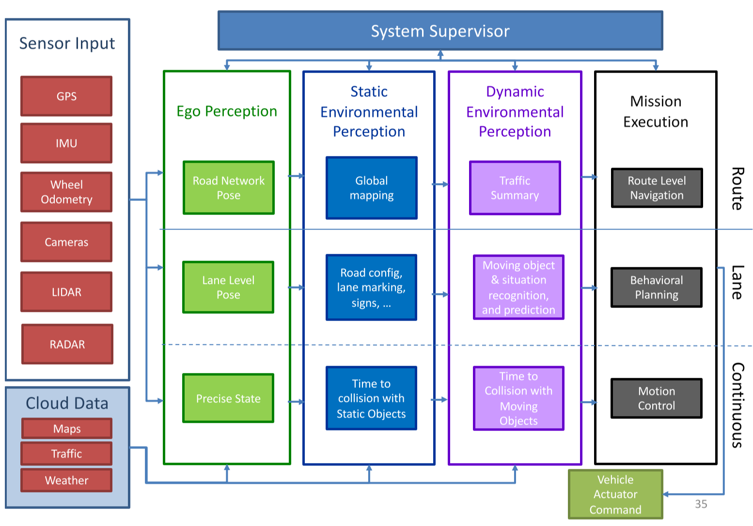

1. **Perception**
   * Sensor input: GPS, IMU (inertial measurement unit), wheel odometry, cameras , LiDAR (laser scanner), radar
   * Cloud data: maps, weather, traffic
   * Ego perception
     + Road network pose
     + Lane level pose
     + Precise state
   * Static environmental perception
     + Global mapping
     + Road config, lane marking, signs
     + Time to collision with static objects
   * Dynamic environmental perception
     + Traffic summary
     + Moving object and situation recognition
     + Time to collision with moving objects
2. **Decision-Making**
   * Mission execution: route-level navigation and behavioural planning
3. **Control**
   * Mission execution: motion control

# 1-2 ADS: Autonomoose

## Baseline Architecture

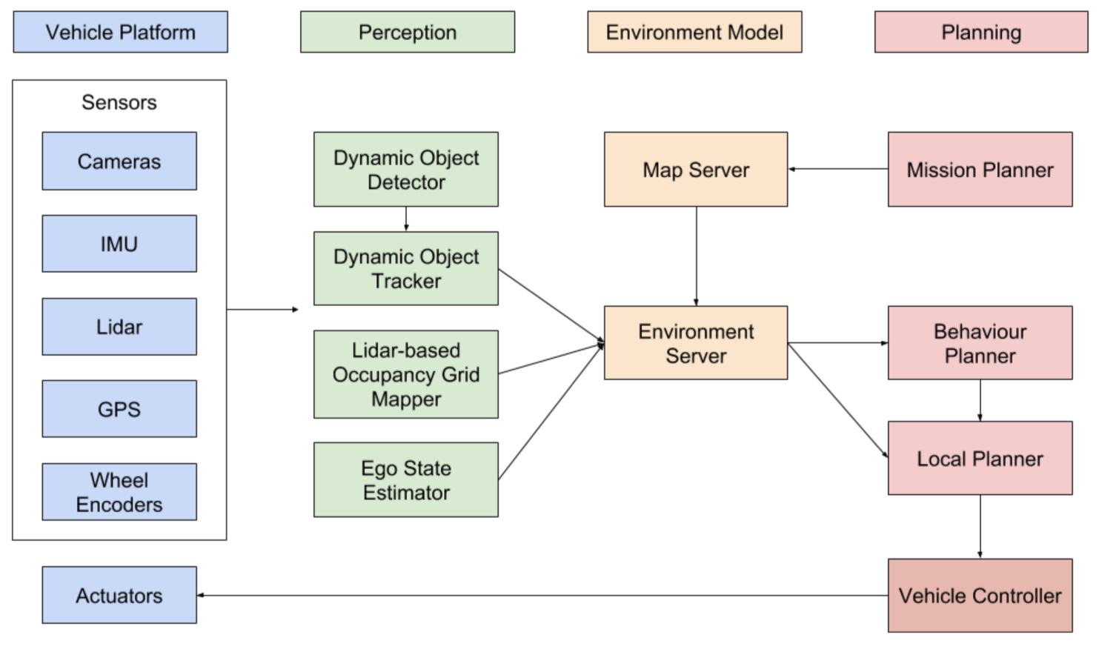

* LiDAR + 8 cameras
* Localization done by LiDAR scan matching, which produces lanelets
* Static obstacle detection done using **LiDAR occupancy grid**
* 3D object detection determined through **deep neural network**
* Dynamic object detectiondone using **Aggregate View Object Detection (AVOD)**
* Dynamic object trackingdone using **Kalman filter**
* Planning:
  + **Behavioural planner** – rule-based
  + **Trajectory planner** – optimization-based / static object avoidance
* Testing methods:
  + Computer simulation testing
  + Closed course testing
  + Field testing

# 1-3 ADS: State of Automated Driving

* Scene understanding
* 2D object detection
* 3D object detection
* Prismatic bounding volumes
* **Image segmentation** – separating images into different regions
* **Instance-level** **segmentation** – assigns label to each pixel in an image
* **Point-cloud segmentation** – classifies clouds of points into regions
* **Stixel representation** – a medium-level model of the environment that is specifically designed to compress information about obstacles by leveraging the typical layout of outdoor traffic scenes

## Challenges

* Bad at handling divergence due to emergencies/accidents
* Motion isn’t very smooth
* Lane changes are slow
* Bad at sharp left turns
* Doesn’t abide by some driving rules
* Keeps braking

# 2-1 Computer Vision: Image Representation

* Images are multi-dimensional arrays

## Image Types

* Binary image – binary value per pixel (B/W)
* Intensity image – light intensity value per pixel
* Color image – multiple values per pixel

## RGB: Red, Green, Blue

* Widely used by electronic media (TV, computer monitor, etc.) to generate light
* Additive mixing of primary colours red, green, and blue
* Each colour stimulates one of the eye’s three types of colour receptors
* Sensitive to colour of light, which creates problems because there are different shades

## HSV: Hue, Saturation, Value

* **Hue** – angle
* **Saturation** – distance from axis
* **Brightness** – distance along axis (black to white)
* RGB 🡪 HSV is a non-linear transformation
* Advantages of HSV:
  + More robust colour selection than RGB
  + Less sensitive to changes in lighting than RGB

*** Doesn’t matter which one to feed to neural network, if doing manual computer vision, because eventually the neural network will learn the proper transformation for either ***

# 2-2 Computer Vision: Filtering

## Image Operations (Functions Over Images)

### Point Operations

* Output pixel depends on corresponding input pixel only, possibly with some global information or parameter



* + Colour transforms
  + Brightness and contrast adjustment
  + Gamma correction
  + Image addition/subtraction

### Linear Filters

* Output pixel is a linear combination (weighted sum) of corresponding input pixel and its neighbours

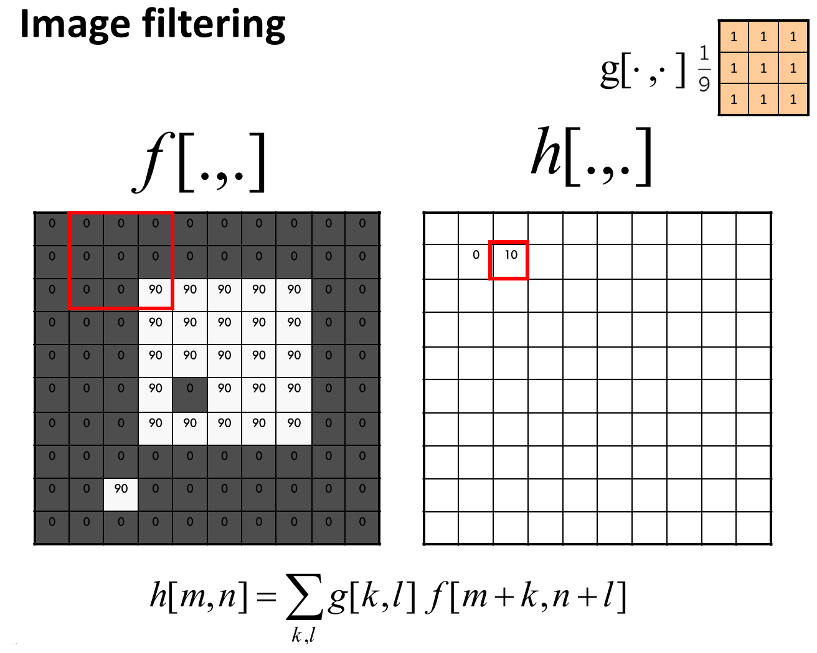

* Each coordinate $h[m,n]$ in the output image is computed as the sum of multiplying each coordinate $g[k,l]$ of the filter by the corresponding section of input image $f[m+k,n+l]$
* Example above: $m=1, n=2$

$$h\left[1,2\right]=\frac{1}{9}\left(\left(1×0+1×0+1×0\right)+\left(1×0+1×0+1×0\right)+\left(1×0+1×0+1×90\right)\right) \\ =10$$

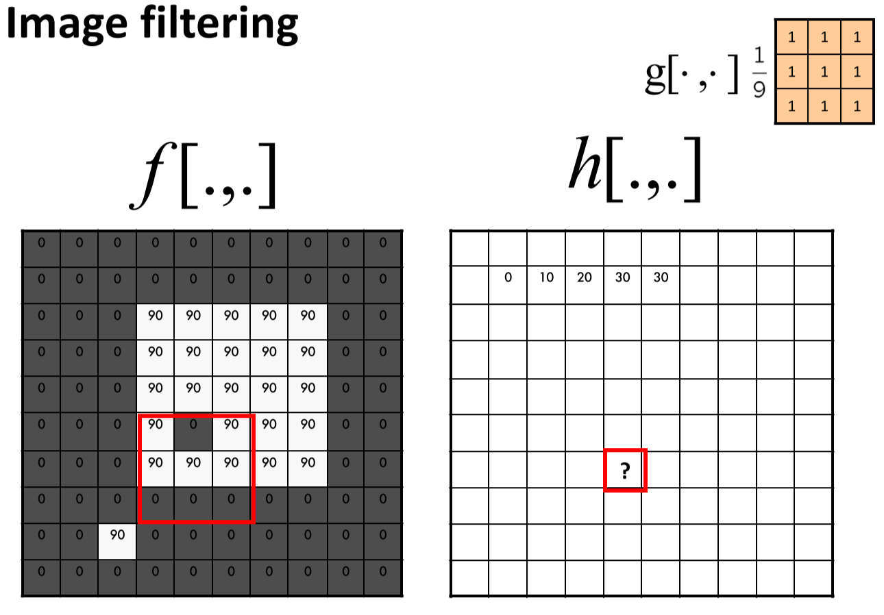

* Example above: $m=6, n=4$
$$h\left[6,4\right]=\frac{1}{9}\left(\left(1×90+1×0+1×90\right)+\left(1×90+1×90+1×90\right)+\left(1×0+1×0+1×0\right)\right) \\ =50$$

* Properties of Linear Filters:
  + **Superposition**: $h\left(f_{1}+f_{2}\right)=h\left(f_{1}\right)+h\left(f_{2}\right)$
  + **Shift-invariant**: output of a shifted image is same but shifted

$$g\left(i,j\right)=f\left(i+k,j+l\right)⇔h\left(g\right)\left(i,j\right)=h(f)(i+k,j+l)$$

### Box Filters

* Replaces each pixel with an average of its neighbourhood
* Achieves smoothening effect – removes sharp edges

## Cross-Correlation vs. Convolution

* Cross-correlation: $h\left[m,n\right]=\sum_{k.l}{g\left[k,l\right]f[m+k,n+l]}$
  + Neither associative nor commutative
* Convolution: $h\left[m,n\right]=\sum_{k.l}{g\left[k,l\right]f[m-k,n-l]}$
  + Convolution can be performed using cross-correlation, by flipping kernel horizontally and vertically
  + If kernel is symmetric, cross-correlation and convolution coincide
  + Properties:
    - **Commutative**: $f*g=g*f$
    - **Associative**: $f*\left(g*h\right)=\left(f*g\right)*h$

## Convolution Theorem

$$F\left\{f*g\right\}=k F\left\{f\right\} F\{g\}$$

* $F$ = Fourier transform
* Convolutions are multiplications in the Fourier space – represents passing a signal through a **linear shift-invariant (LSI) filter**
  + Kernel function $h$ is the impulse response function, because $h$ convolved with an impulse signal reproduces itself
* Convolution theorem tells us that filtering via convolution can be understood as **frequency filtering**
 $$F\left\{I*h\right\}=k F\left\{I\right\} F\{h\}$$

 + Convolving a filter $h$ with an image $I$ is the same as multiplying the Fourier coefficients of the filter and image together

### Practice Convolution vs. Cross-Correlation

* **1D convolution**:

Impulse convolved with signal = signal

$$\left[0 1 0\right]*\left[1 2 3\right]=\left[0 1 0\right]*\left[3 2 1\right]=[3 2 1] \\ \left[0 1 0\right]*\left[3 2 1\right]=[1 2 3]$$

$$\left[1 2 3\right] ⨂ \left[0 1 0\right]=[1 2 3]$$

* **1D cross-correlation**:

$$\left[0 1 0\right] ⨂ \left[1 2 3\right]=\left[\left(0×1+1×1+0×1\right) \left(0×2+1×2+0×2\right) \left(0×3+1×3+0×3\right)\right] \\ =[1 2 3] \\ \left[1 2 3\right] ⨂ \left[0 1 0\right]=[1 2 3]$$

## Padding

* Padding the source avoids shrinkage of filter output size
* Types:
  + Zero – set all pixels outside the image to 0
  + Clamp – repeat edge pixels indefinitely; most commonly used
  + Wrap – loop around image in toroid; plays nicely with Fourier transform

## Linear Filters Practice

**Impulse Function (Kronecker Delta Function)**

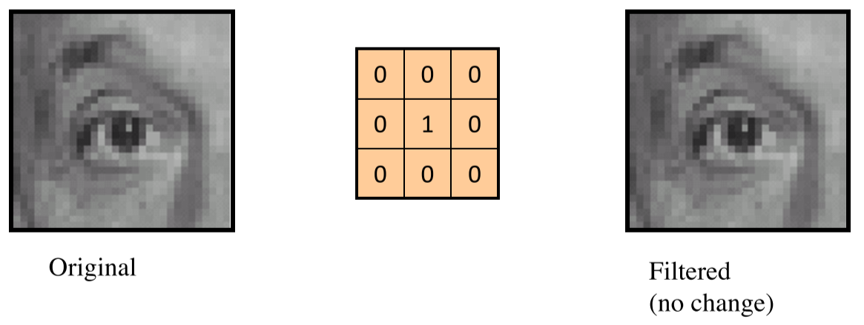

**Left Shift by One Pixel**

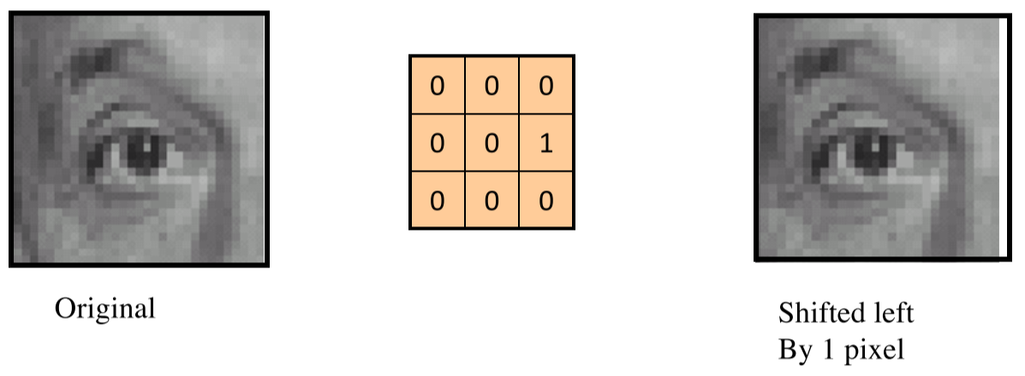

**Sharpening Filter**

* Accentuates differences in local average

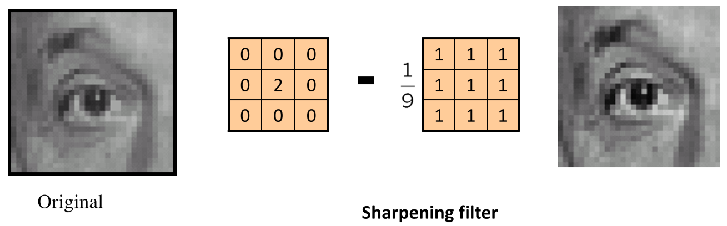

## Gaussian Blur

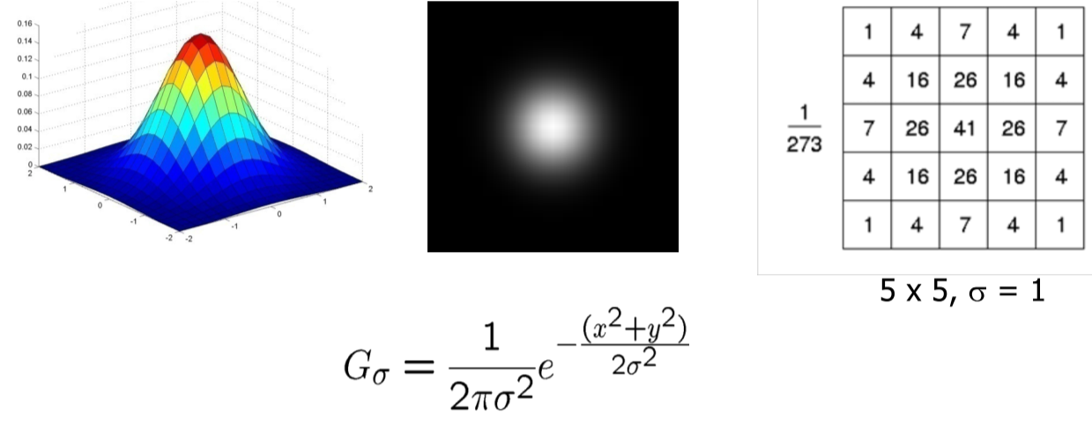

* Spatially-weighted average
  + Kernel samples the continuous Gaussian function
  + Function is clipped at kernel edge
* Coefficients must add up to 1, or the filter brightens/darkens the image
* Parameters:
  + **Variance $σ^{2}$** : determines extent of smoothing
  + **Mask width $w$** : usually, $w=5σ$ to cover $98.76\%$ of the area under the Gaussian curve
    - For a 3x3 filter, $σ=0.6 pixel$

|  |  |  |
| --- | --- | --- |
| 1 | 2 | 1 |
| 2 | 4 | 2 |
| 1 | 2 | 1 |

$$\frac{1}{16}$$

* Gaussian function is **separable**: computing Gaussian in horizontal direction followed by vertical is much faster

## Non-Linear Filters

* Do not satisfy the superposition property
* Examples:
  + Thresholding
    - Threshold operator is non-linear, because, individually, corresponding pixels in two images A and B may be below the threshold, but their sum A + B may be above it
  + Median filtering
  + Bilateral filtering
  + Morphological filters

## Thresholding

* Creates a binary image based on a set level/threshold: $$g\left(x,y\right)=\left\{\begin{aligned}1 when f\left(x,y\right)>T \\ 0 when f\left(x,y\right)≤T\end{aligned}\right.$$
* **Image masking**: pixelwise multiplication
* **Selecting an image with a certain colour**:
  + Identify pixel value range for colour of interest in hue plane
  + Threshold image, using colour range to create binary mask
  + Apply mask to original image
* **How do we know where to threshold?**
  + Use a histogram over an image patch that contains the coloured object of interest and some background – apply threshold to histogram values

## Region of Interest (ROI)

* Parts of an image that should be used for further processing
* Can be different shapes
* ROI can be applied by:
  + Masking
  + Cropping
  + Feature selection from a list (e.g. line segments), based on position

## Image Sampling

* **Down-sampling**: image gets smaller
* **Up-sampling**: image gets bigger
* **Image scaling/subsampling**: throw away every other row and column to create ½ size picture
  + **Aliasing**: occurs when sampling rate isn’t high enough to capture details in image
    - Gives you the wrong signal/image
    - Images contain structure at different scales/frequencies
    - Nyquist theorem: sampling must be 2x the highest frequency in the image to avoid aliasing
  + Solution: apply Gaussian filter, then subsample

## Morphological Operations

* Change the shape of objects in binary images
* Operations include:
  + **Dilation** – enlarge a region
  + **Erosion** – shrink a region
  + **Closing** – close internal holes
  + **Opening** – remove small pieces

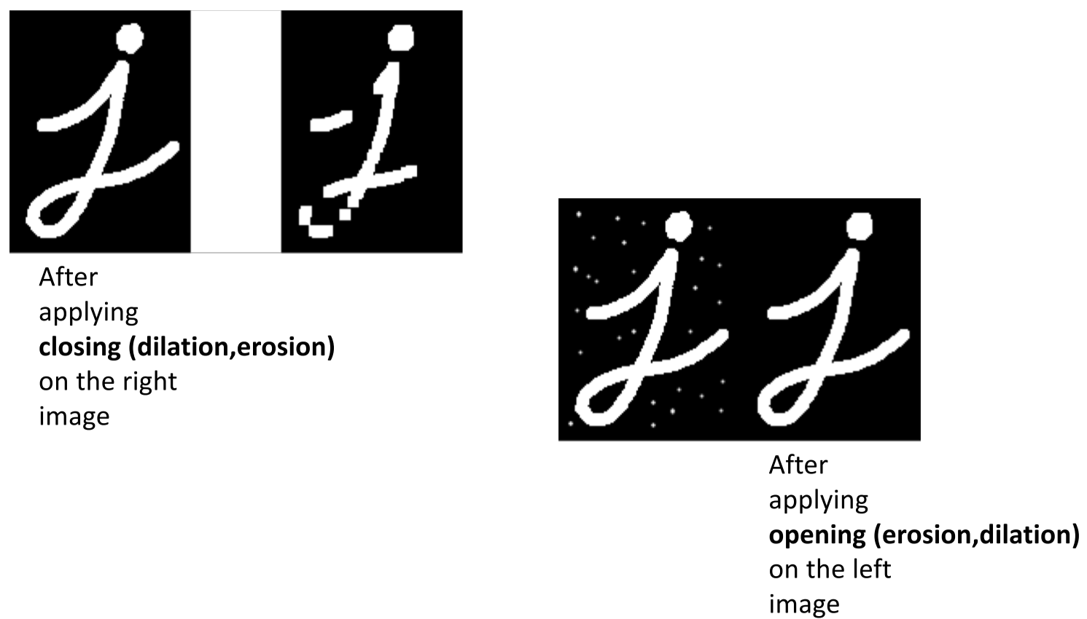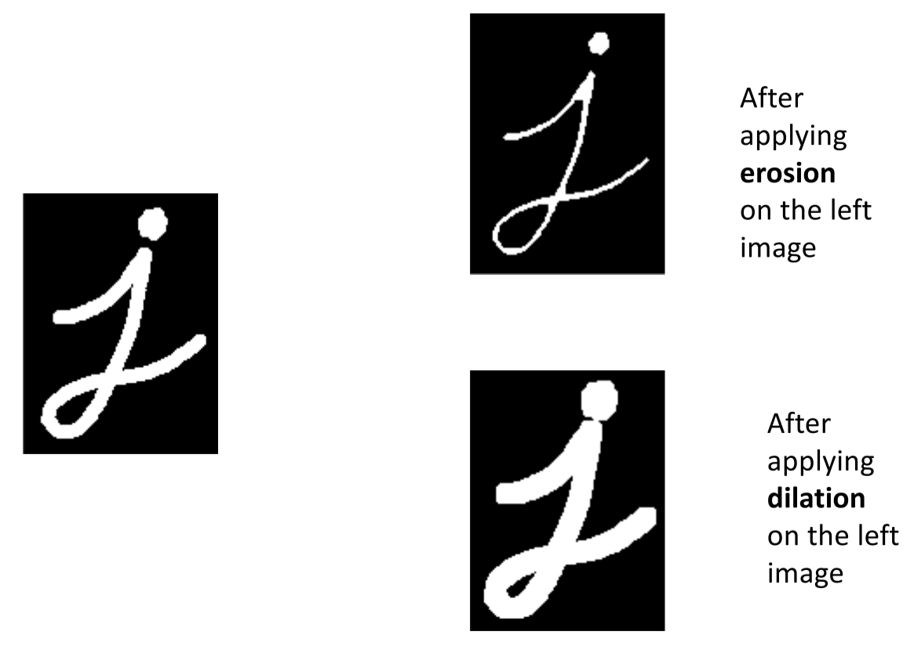

# 2-3 Computer Vision – Image Features

* Image features are local, meaningful, detectable parts of an image
  + **Low-level features** – e.g. points and patches, edges, lines, and splines
  + **High-level features** – e.g. nose, mouth in a portrait
* Feature descriptor: set of properties of an image feature
  + Characteristics that define the feature and make it unique
  + May include feature location in the image

# 2-4 Computer Vision – Edges and Lines

## Characterizing Edges

* An edge is a place of rapid change in the **image intensity function**
  + Edges correspond to extrema (max/min) of derivative

### Image Gradient

* The gradient of an image points in the direction of the most rapid change in intensity

$$∇f=\left[\frac{∂f}{∂x},\frac{∂f}{∂y}\right]$$

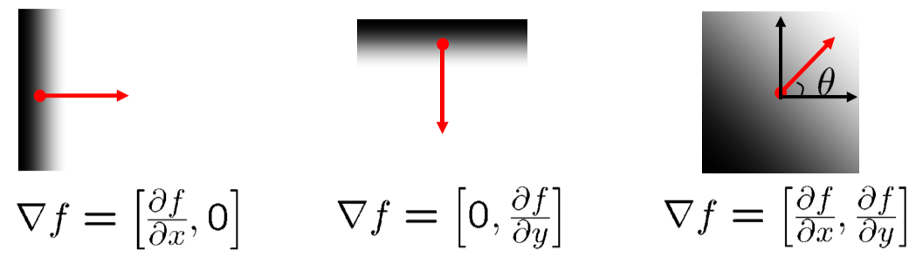

### The Discrete Gradient

How to differentiate a digital image $F[x,y]$?

$$\frac{∂f}{∂x}\left[x,y\right]≈F\left[x+1,y\right]-F[x,y]$$

* Implemented as linear filter: [-1, 0, 1]
* The **discrete gradient** is given by: $$θ=\tan^{-1}\left(\frac{∂f}{∂x}/\frac{∂f}{∂y}\right)$$ 
  + It is perpendicular to the direction of the edge
* The **edge strength** is: $$\left\|∇f\right\|=\sqrt{{\left(\frac{∂f}{∂x}\right)}^{2}+{\left(\frac{∂f}{∂y}\right)}^{2}}$$

## Sobel Filter

Combines gradient and smoothing

|  |  |  |
| --- | --- | --- |
| -1 | 0 | 1 |
| -2 | 0 | 2 |
| -1 | 0 | 1 |

|  |  |  |
| --- | --- | --- |
| -1 | -2 | -1 |
| 0 | 0 | 0 |
| 1 | 2 | 1 |

$$g_{y}=$$

Magnitude: $g=\sqrt{g_{x}^{2}+g_{y}^{2}}$

Orientation: $θ=\tan^{-1}\left(\frac{g_{y}}{g_{x}}\right)$

## Effects of Noise

* Different filters respond strongly to noise
  + Image noise results in pixels that look very different from their neighbours
  + The larger the noise, the stronger the response
* Solution: smooth first, then edges are peaks in $\frac{∂}{∂x}(h*f)$

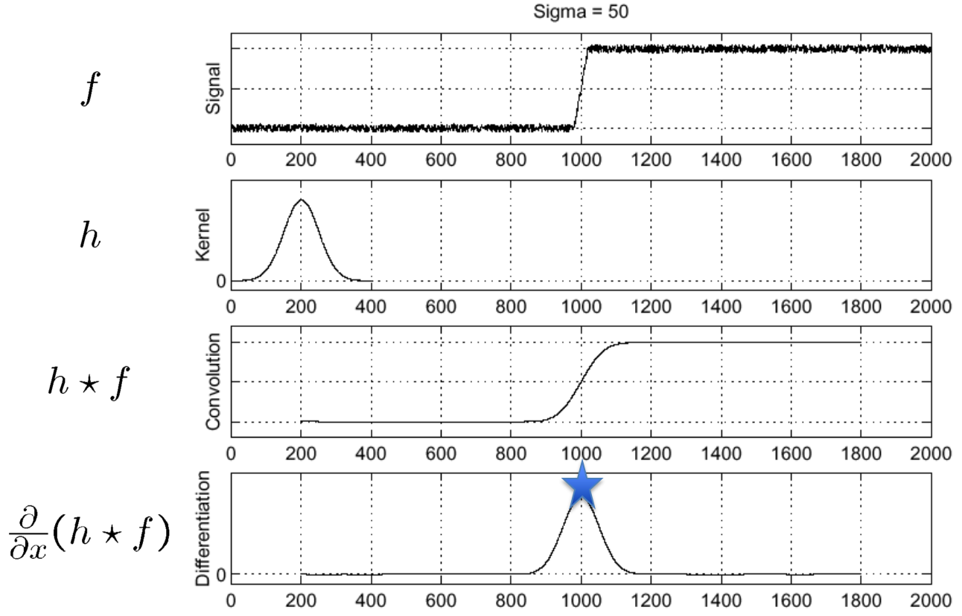

* Since differentiation is convolution, and convolution is **associative**: $$\frac{∂}{∂x}\left(h*f\right)=f*\frac{∂h}{∂x}$$

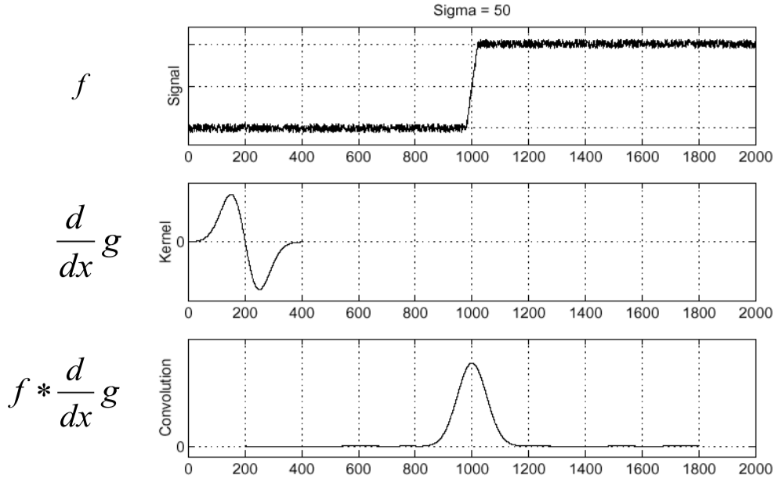

### Resulting Filter: Derivative of Gaussian (DoG) Filter

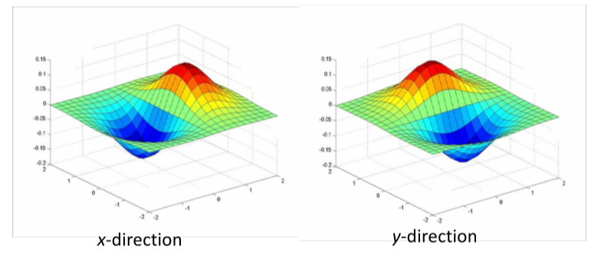

* Use thresholding to find the edge

## 2D Edge Detection Filters

* **Laplacian of Gaussian (LoG)**: $$∇^{2}f=\frac{∂^{2}f}{∂x^{2}}+\frac{∂^{2}f}{∂y^{2}}$$ 
  + Zero far away from the edge
  + Positive on one side
  + Negative on the other side
  + Zero right at the edge

### Canny Edge Detector

Input: grayscale image

1. Remove noise – Gaussian smoothing
2. Compute gradient – gradient X and gradient Y, magnitude, and orientation
3. Find thin edges – **non-max suppression** finds maximum gradient pixels for thin edges
4. Remove unwanted edges – **hysteresis thresholding** (upper and lower threshold)

Output: binary image

* Gives single-pixel-wide edges with good continuation between adjacent pixels
* Most widely-used edge operator today
* Very parameter-sensitive – must be adjusted for different use cases

### Non-Maximum Suppression

* Map gradient orientation $θ$ of each pixel to $45°, 90°, 135°,$ or $0°$
* Keep middle pixel if local max is along gradient direction, otherwise suppress

### Hysteresis Thresholding

* Accepts strong edges and weak edges connected to strong edges
  + Above upper threshold: strong edge – accept
  + Between upper and lower threshold: accept only if connected to strong edge
  + Below lower threshold: reject

# 2-5 Computer Vision – Lines

## Hough Transform

* Voting scheme to find lines in an image, which narrows down the search
  + A point votes for any line that may go through it
  + A gradient orientation votes for a perpendicular line at that location
* **Hough Space** transforms lines $y=m_{0}x+b_{0}$ into points in the $(m,b)$ domain
  + Lines in an image correspond to points in the Hough space
  + Transformation: given a point $(x,y)$, find all $(m,b)$ such that $y=mx+b$
  + What does a line in the image space map to in the Hough space?
    - Infinitely many lines, all intersecting at point

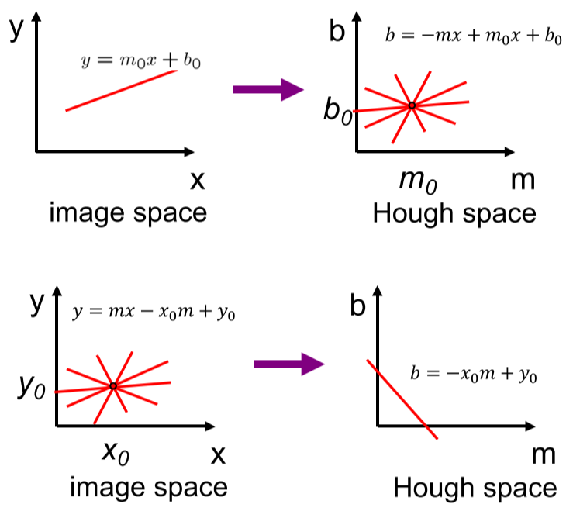

* + What does a point in the image space map to in the Hough space?
    - A line
  + What does a point in the Hough space map to in the image space?
    - A line
  + What does a line in the Hough space map to in the image space?
    - Infinitely many lines, all intersecting at point $(x,y)$



* Strong indication of a line in the image space = places where many lines intersect in the Hough space
* For more general line representation, use polar coordinates

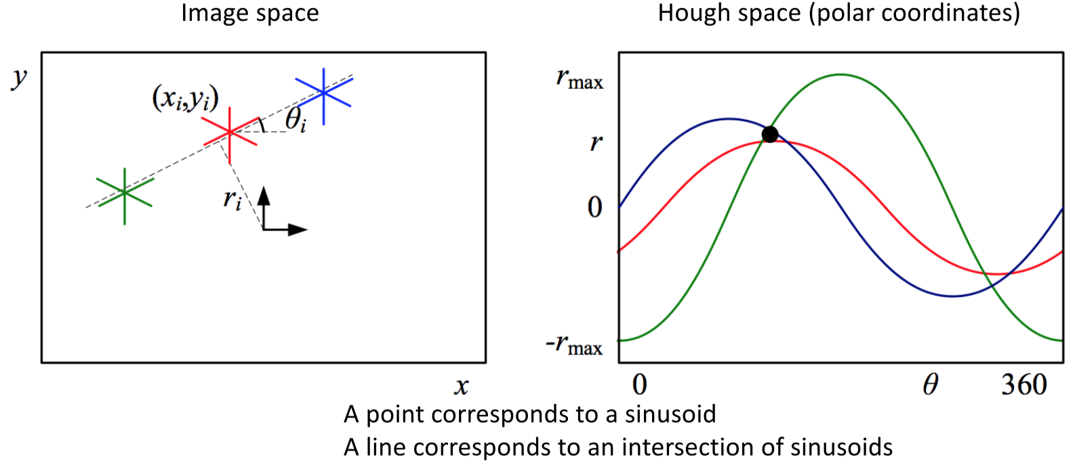

* + Point in image space = sinusoid in Hough space
  + Line in image space = intersection of sinusoids in Hough space
* **Probabilistic Hough Transform** finds line segments instead of lines

# 2-6 Machine Learning: Linear Regression

## Linear Regression

* Assignment 1: fit Hough line segments into lane lines
* **Linear regression** fits a line into a set of points
* How to select the best fit?

## Least Squares Estimate

* Minimize the sum of squared errors

### Simple Case

Zero intercept ($b=0$) with Gaussian error $ε$

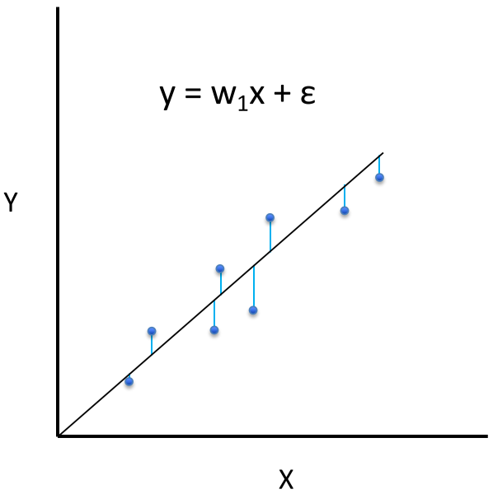

* Least squares estimate: $${\hat{w}}_{1}={argmin}_{w_{1}}\sum_{i}{ε^{2}}={argmin}_{w_{1}}\sum_{i}{{(y_{i}-w_{1}x_{i})}^{2}}$$
  + Value of $w_{1}$ that provides the smallest sum of squared errors
* **Closed-form solution**: take the derivative and set it to 0: $$\frac{∂}{∂w_{1}}\sum_{i}{{\left(y_{i}-w_{1}x_{i}\right)}^{2}}=2\sum_{i}{-x_{i}\left(y_{i}-w_{1}x_{i}\right)} \\ 2\sum_{i}{x_{i}y_{i}-{\hat{w}}_{1}x_{i}^{2}}=0 \\ 2\sum_{i}{x_{i}y_{i}}=2\sum_{i}{{\hat{w}}_{1}x_{i}^{2}} \\ {\hat{w}}_{1}=\frac{\sum_{i}{x_{i}y_{i}}}{\sum_{i}{x_{i}^{2}}}$$

### With bias term $w_{0}$

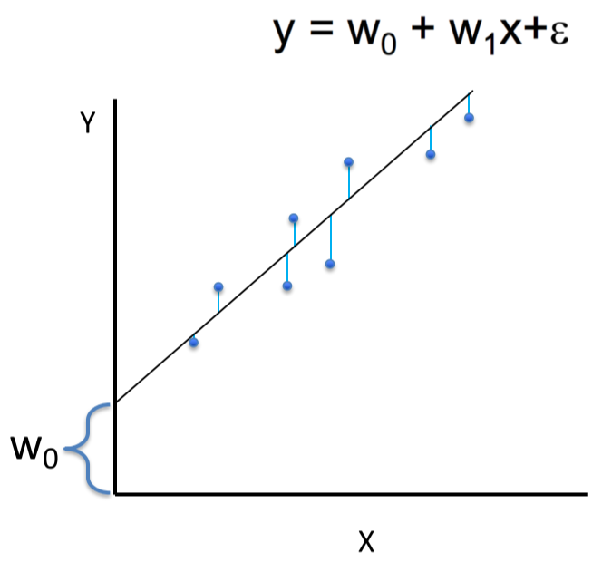

$${\hat{w}}_{0}=\overline{y}-{\hat{w}}_{1}\overline{x}$$

$$\overline{y}=\frac{\sum_{i}{y_{i}}}{n},\overline{x}=\frac{\sum_{i}{x_{i}}}{n}$$

$${\hat{w}}_{1}=\frac{Conv\left(x,y\right)}{Var(x)}=\frac{\sum_{i}{(x_{i}-\overline{x})}(y_{i}-\overline{y})}{{\sum_{i}{\left(x_{i}-\overline{x}\right)}}^{2}}$$

### Least Squares Assumptions

* Each data point is corrupted by Gaussian noise
* Errors across data points are identically and independently distributed
* Each data point has the same weight
* Least squares estimate is very sensitive to **outliers** (points far away from other points)

## Random Sample Consensus (RANSAC)

* Given a model, find the smallest number of samples $M$ from which the model can be computed
* Algorithm:
  1. Randomly select $M$ sample from data
  2. Compute model parameters using $M$ samples
  3. Check how many samples from the rest of the data fit the model – this is the number of **inliers $C$**
  4. If $C>C_{threshold}$ or max iterations reached, return best inlier set; else, go back to step 1
  5. Recompute model parameters from best inlier set
* $C_{threshold}$ = **max errors per sample**

## Multivariate Regression

What if there are multiple inputs that the output linearly depends on?

$$y=w_{0}+w_{1}x_{1}+…+w_{k}x_{k}+ε$$

E.g. $y=10+3x_{1}^{ 2}-2x_{2}^{ 2}+ε$

* As long as the coefficients are linear, we can use linear regression after transforming the inputs
* Desired function is a linear combination of **basis functions**
  + Basis functions form a function space:

E.g. function space with single basis function $x^{2}$: $y=w_{0}+w_{1}x_{1}^{ 2}+…+w_{k}x_{k}^{ 2}+ε$

### Non-Linear Basis Functions

* **Polynomial**: $ϕ_{j}\left(x\right)=x^{j} for j=0…n$
* **Gaussian**: $ϕ_{j}\left(x\right)=\frac{x-μ_{j}}{2σ_{j}^{ 2}}$
* **Sigmoid**: $ϕ_{j}\left(x\right)=\frac{1}{1-e^{-s_{j}x}}$

## General Linear Regression Problem

$$y=\sum_{j=0}^{k}{w_{j}ϕ_{j}\left(x\right)}$$

* $ϕ_{j}\left(x\right)$ is any basis function

### Least Squares for General Linear Regression Problem

Goal: minimize the loss function

$$J\left(w\right)=\sum_{i}{{\left(y_{i}-\sum_{j}{w_{j}ϕ_{j}\left(x^{i}\right)}\right)}^{2}}$$

Using vector notation:



$$J\left(w\right)=\sum_{i}{{\left(y_{i}-w^{T}ϕ_{j}\left(x^{i}\right)\right)}^{2}}$$

Deriving $w:$



$$w={\left(ϕ^{T}ϕ\right)}^{-1}ϕ^{T}y$$

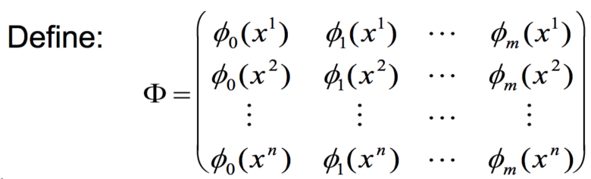

# 3-1 Machine Learning: Introduction

## Machine Learning

* A computer program learns from experience E with respect to some tasks T and performance measures P, if its performance on tasks T, as measured by performance P, improves with experience E
* Types:
  + **Supervised**: learning a function based on labelled data
  + **Unsupervised**: infers function based on unlabelled data
  + **Reinforcement learning**: learning decisions based on feedback

### Supervised Learning

* Given a data set $D\left\{(x_{i},y_{i})\right\}$ of input $x_{i}$ and output $y_{i}$ pairs, learn a model/function $F:x_{k}→y_{k}$
  + $F$ is used to “predict” new output on new (unseen) input data
* Two types:
  + **Classification**: $y_{i}$ are category labels
  + **Regression**: $y_{i}$ are real numbers
* Example: Image classification
  + Set of discrete labels – high-level semantic category
  + Images are represented as 3D arrays of integers [0, 255] (colours)
  + Data-driven approach:
    - Collect dataset of images and labels
    - Use ML to train an image classifier
    - Evaluate the classifier on a withheld set of test images

**Key Challenges in Object Classification**

* Viewpoint variation
* Scale variation
* Illumination conditions
* Deformation
* Occlusion (parts are blocked)
* Background clutter
* Can fall into multiple classes

# 3-2 Machine Learning: Linear Classifier

## Binary Classification

* Learning a function from data labelled with two possible classes
* Example: exam outcome vs. number of hours studied for a sample of students
  + Labels: pass/fail
  + Task: learn a function that predicts pass/fail for a given number of hours studied

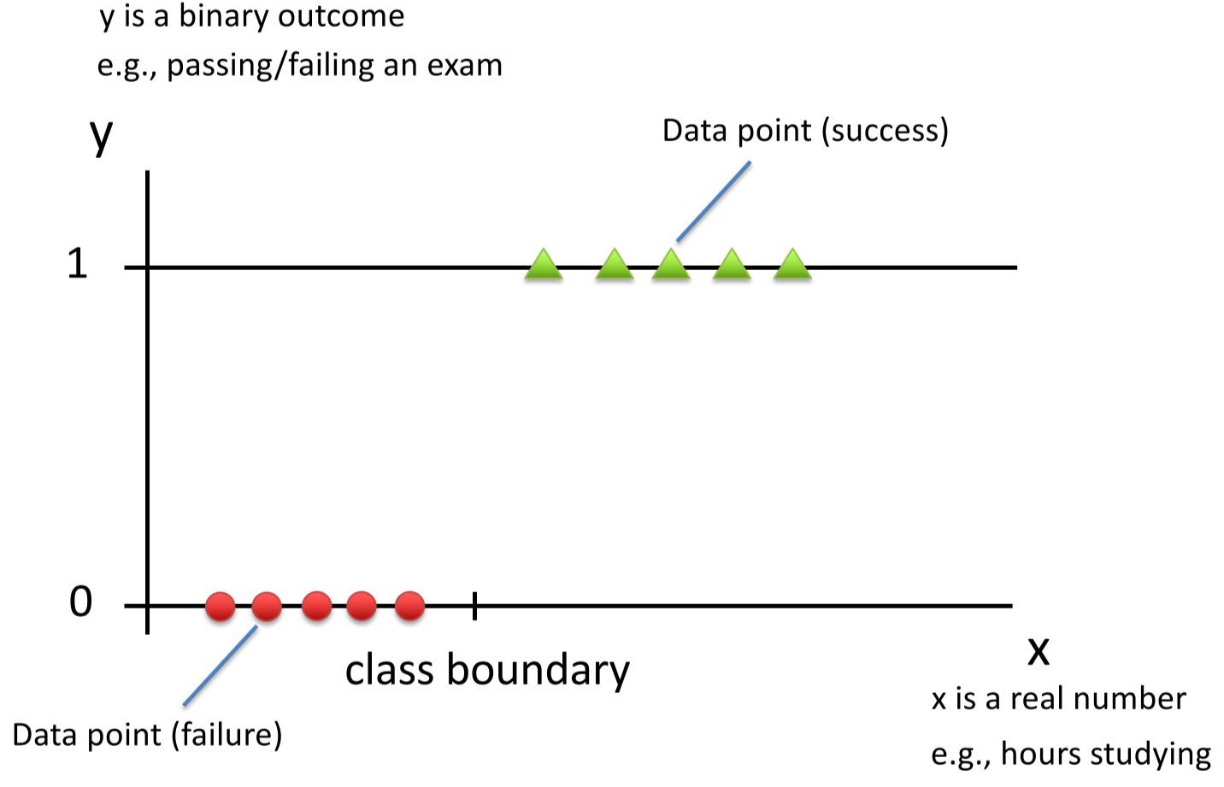

* Possible model: step function
* But the class boundary is fuzzy – some students need more study hours to pass, and the step function is bad for optimization  
  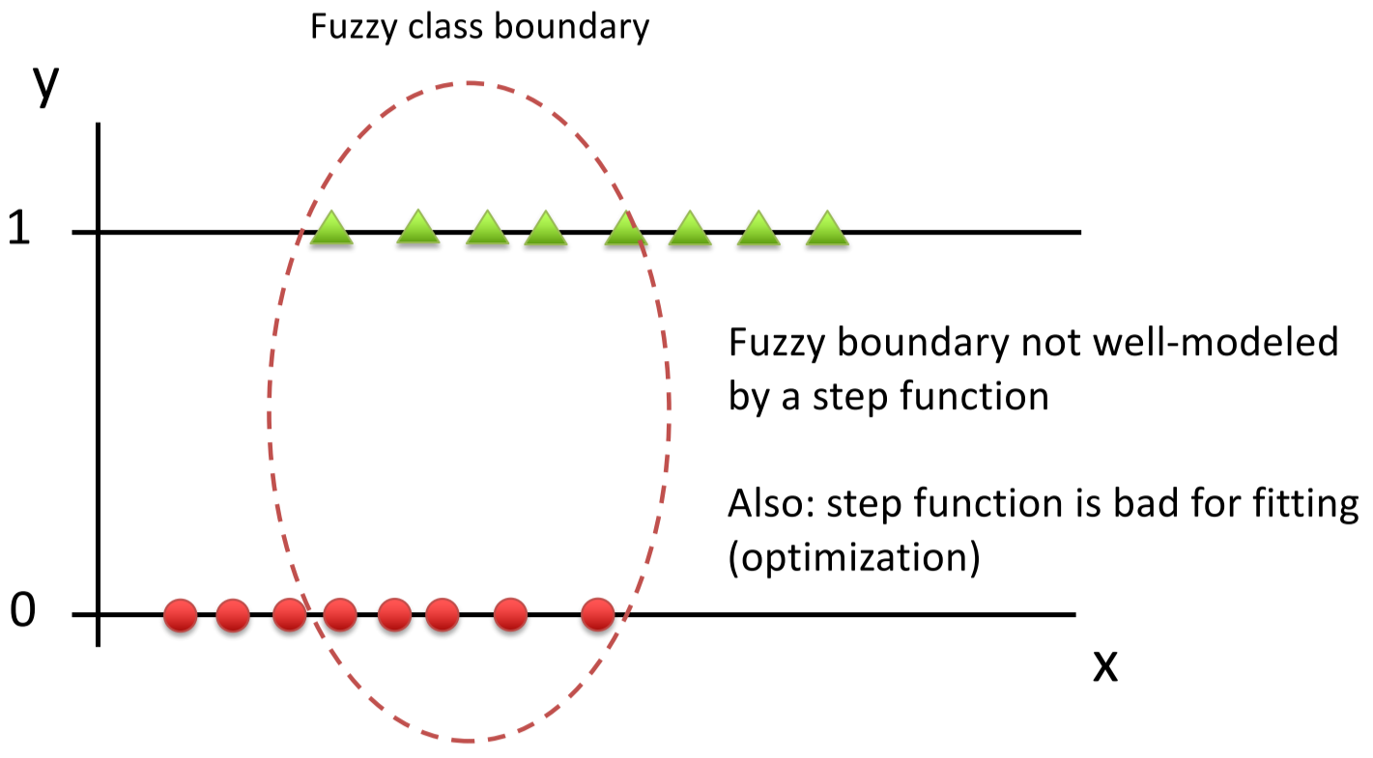
* Better model: **sigmoid function**

## Sigmoid Function (Logistic Regression)

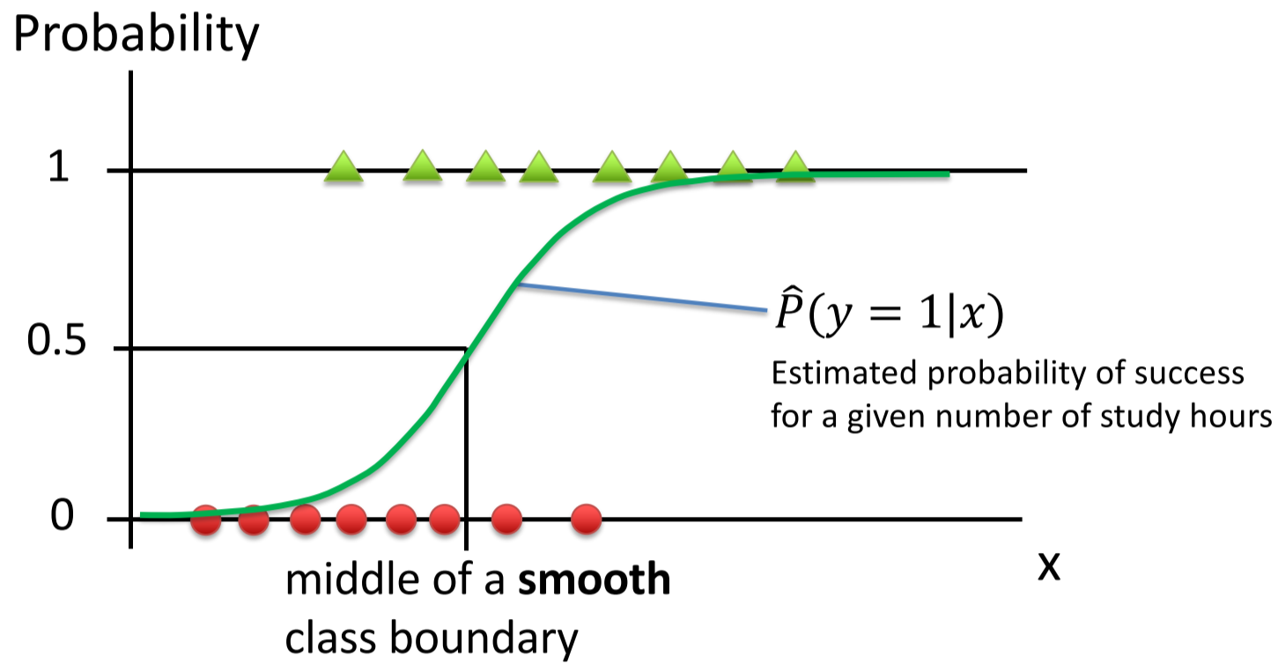

A commonly used sigmoid is the Logistic Function:

$$S\left(x\right)=\frac{e^{x}}{e^{x}+1}=\frac{1}{1-e^{-x}}$$

### Sigmoid Fitting with Two Parameters

$$P\left(y=1 | x;w_{0},w_{1}\right)=S\left(w_{1}x+w_{0}\right)=\frac{1}{1-e^{-(w_{1}x+w_{0})}}$$

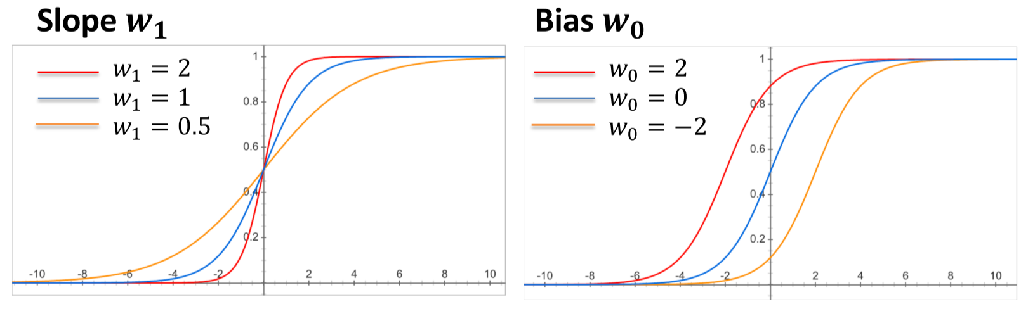

* **Slope = $\frac{1}{w_{1}}$** dictates the width of the boundary
* **Bias = $-w_{0}$**  dictates the location of the boundary midpoint (left/right shift)

### Bernoulli Distribution (Aside)

The distribution of a binary random variable $X$, which takes value 1 with probability $p$ and value 0 with probability $1-p$.

$$Ber_{X}\left(p\right)=p^{X}{\left(1-p\right)}^{1-X}=\left\{\begin{aligned}p, if X=1 \\ 1-p, if X=0\end{aligned}\right.$$

$$P\left(X=1\right)=p \\ P\left(X=0\right)=1-p$$

## Logistic Regression Model

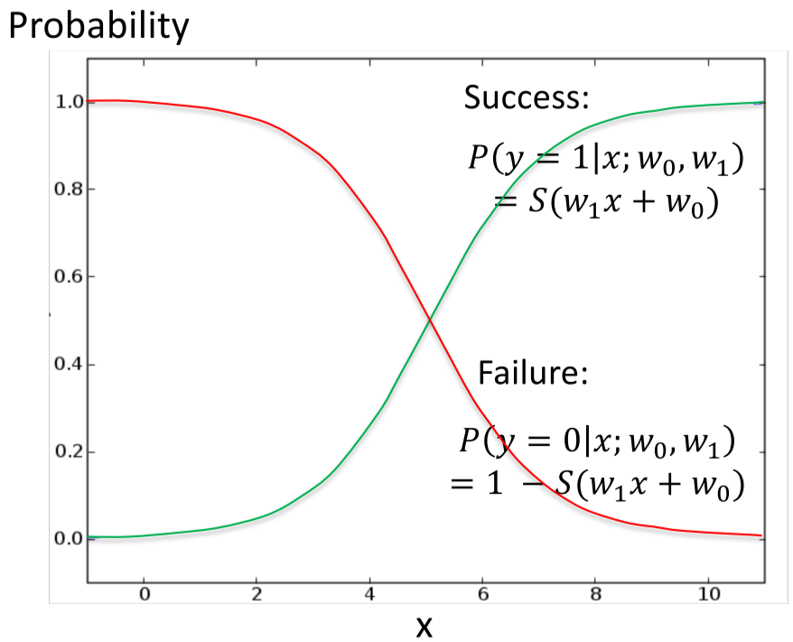

Complete model = probability of success + probability of failure

$$P\left(y | x;w_{0},w_{1}\right)=Ber_{y}\left[S\left(w_{1}x+w_{0}\right)\right] \\ =S{\left(w_{1}x+w_{0}\right)}^{y}{\left(1-S\left(w_{1}x+w_{0}\right)\right)}^{1-y}$$

### Training

* Given a dataset $D\{(x_{i},y_{i})\}$, fit parameters ${\hat{w}}_{0}, {\hat{w}}_{1}$ such that the likelihood that the data is produced by $P\left(y | x;{\hat{w}}_{0}, {\hat{w}}_{1}\right)=Ber_{y}\left[S\left({\hat{w}}_{1}x+{\hat{w}}_{0}\right)\right]$ is maximized – this is the **Maximized Likelihood Estimate (MLE)**
* Equivalently, MLE is the minimizing of the **cross-entropy loss**

### Inference

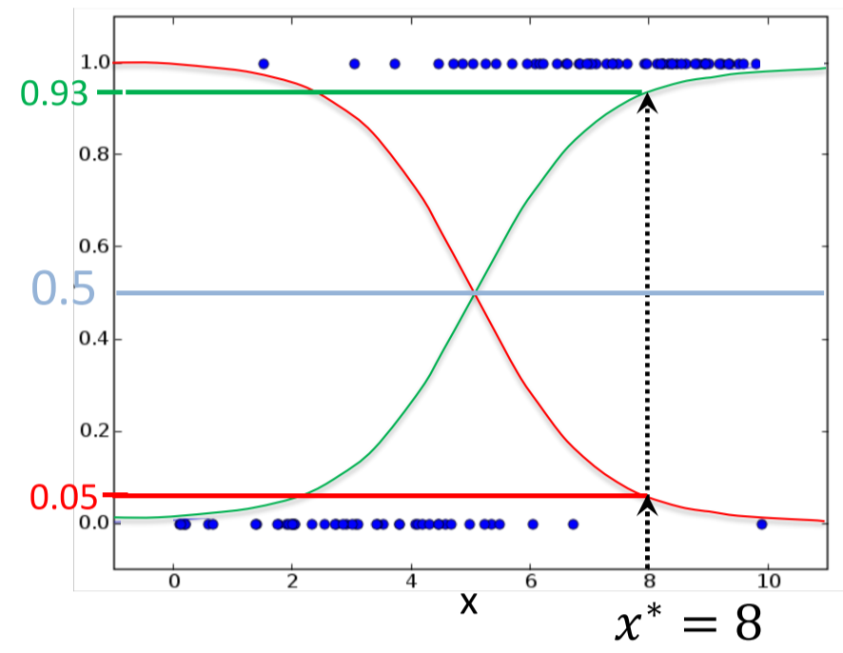

For an input $x^{*}$ (e.g. $x^{*}=8$):

1. Find $P\left(y | x^{*};{\hat{w}}_{0}, {\hat{w}}_{1}\right)$:  
   E.g. $$P\left(y=1 | x^{*}=8;{\hat{w}}_{0}, {\hat{w}}_{1}\right)=0.93 \\ P\left(y=0 | x^{*}=8;{\hat{w}}_{0}, {\hat{w}}_{1}\right)=0.05$$
2. Return the more likely outcome, where threshold = $0.5$: $${\hat{y}}^{*}=\left\{\begin{aligned}1 if P\left(y=1 | x^{*};{\hat{w}}_{0}, {\hat{w}}_{1}\right)>0.5 \\ 0 otherwise\end{aligned}\right.$$ 
   E.g. ${\hat{y}}^{*}=1 if 0.93>0.5=1$

### Fitting Criterion

* Pay a **loss** for each data point that is predicted incorrectly
$$L^{(i)}=-\ln\left(p\right) \\ p=P(y=y^{\left(i\right)}|x^{(i)};w_{0},w_{1})$$

* The **total loss** is the sum of loss for all data points: $$L\left(w_{1},w_{0}\right)=\sum_{i=1}^{n}{L^{\left(i\right)}(w_{1},w_{0})}$$
* **Binary cross-entropy loss**: $$L^{\left(i\right)}=-y^{\left(i\right)}\ln\left(S\left(w_{1}x^{\left(i\right)}+w_{0}\right)\right)-\left(1-y^{\left(i\right)}\right)\ln\left(1-S\left(w_{1}x^{\left(i\right)}+w_{0}\right)\right) \\ =\left\{\begin{aligned}-\ln\left(S\left(w_{1}x^{\left(i\right)}+w_{0}\right)\right) if y=1 \\ -\ln\left(1-S\left(w_{1}x^{\left(i\right)}+w_{0}\right)\right) if y=0\end{aligned}\right.$$

Example:

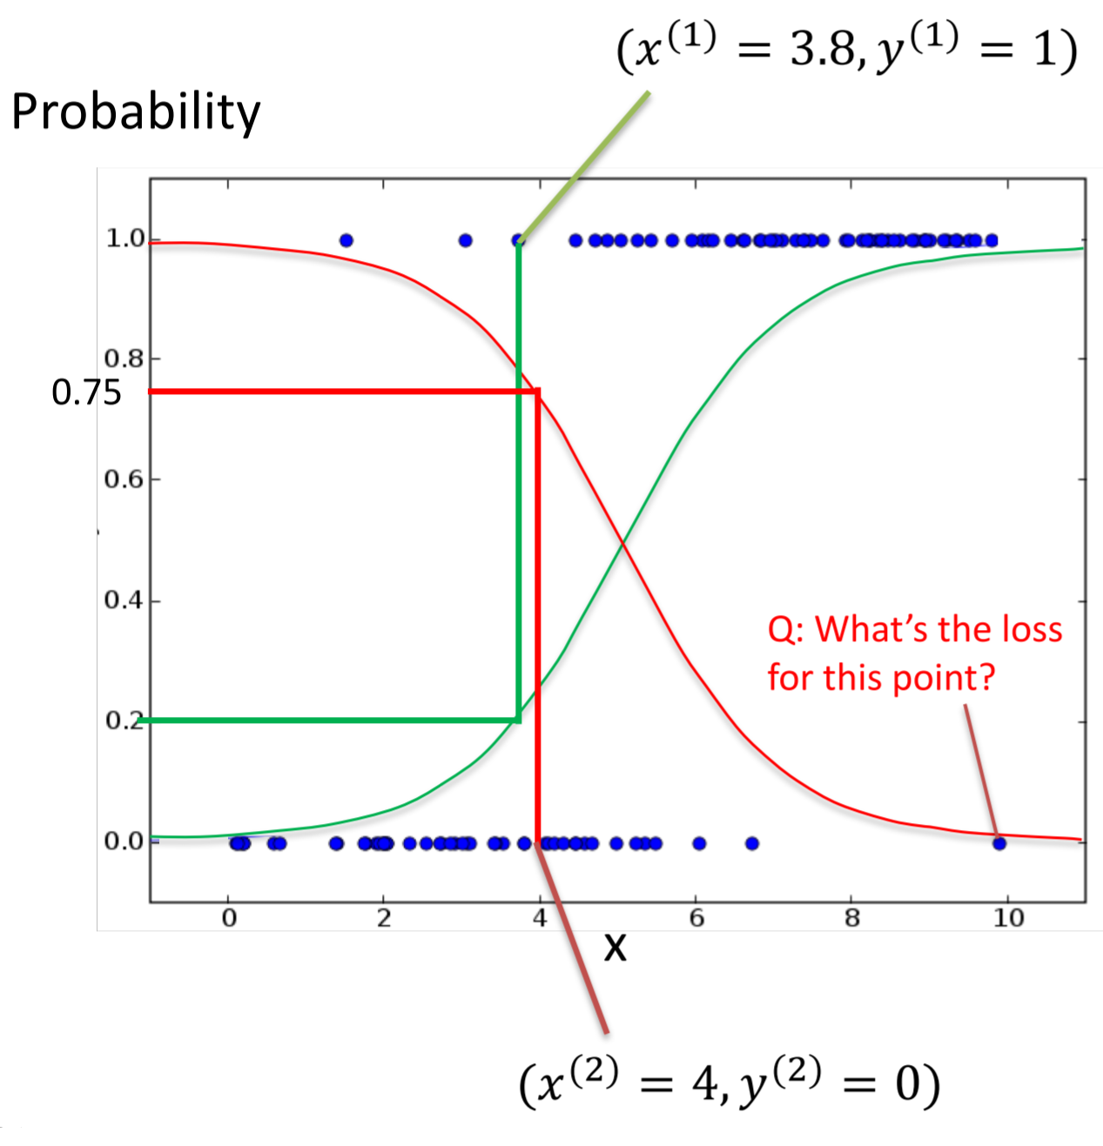

* For $\left(x^{\left(1\right)}=3.8,y^{\left(1\right)}=1\right)$, its class is success
  + The predicted success probability is 0.2, so the loss is $-\ln\left(0.2\right)=1.61$
* For $\left(x^{\left(2\right)}4,y^{\left(2\right)}=0\right)$, its class is failure
  + The predicted failure probability is 0.75, so the loss is $-\ln\left(0.75\right)=0.29$
* It is clear that $\left(x^{\left(1\right)},y^{\left(1\right)}\right)$ incurs higher loss than $\left(x^{\left(2\right)},y^{\left(2\right)}\right)$

### Minimizing Loss

Loss can be minimized using **gradient descent**:  
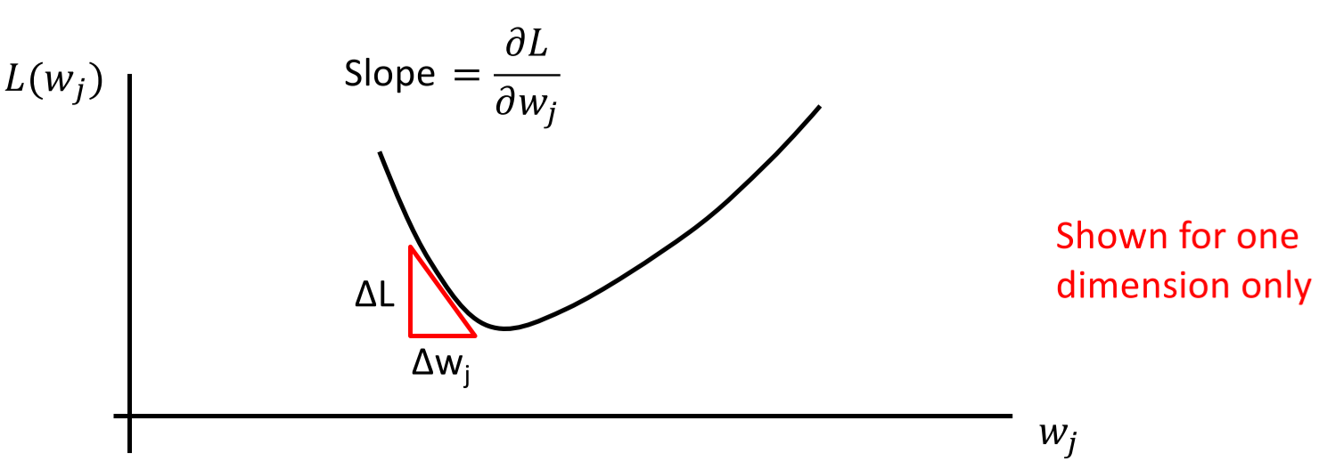

* Going down the slope in the direction opposite to the gradient will lead to smaller L
* Can’t go down too much, or you’ll overshoot the minimum

### Algorithm for Logistic Regression

1. Choose learning rate $ε$
2. Start with a guess for $w_{j}$
3. For all $j$, set $w_{j}=w_{j}-ε\frac{∂}{∂w_{j}}L\left(y | x;w\right) (w=w_{0},w_{1})$
4. If no improvement in $L(y|x;w)$, return $w$; else, go back to step 3

## Multivariate Logistic Regression



$$P\left(y|x;w\right)=Ber_{y}[S(w^{T}⋅x)]$$

$$w^{T}⋅x=w_{0}x_{0}+w_{1}x_{1}+…+w_{m}x_{m}$$

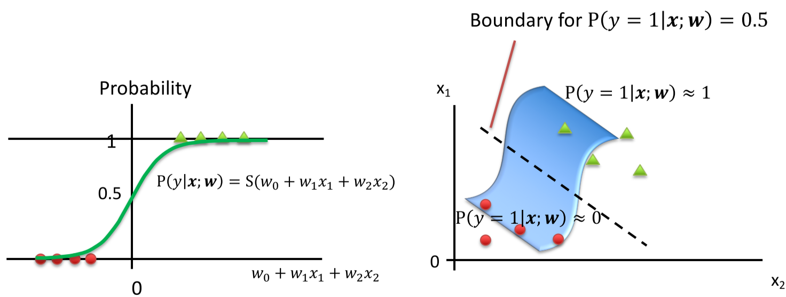

### Training Multivariate Logistic Regressor

Given a dataset:

$$X=\left[\begin{matrix}1 & x_{1}^{(1)} & … & x_{m}^{(1)} \\ 1 & x_{1}^{(2)} & … & x_{m}^{(2)} \\ … & … & … & … \\ 1 & x_{1}^{(n)} & … & x_{m}^{(n)}\end{matrix}\right], y=\left[\begin{matrix}y^{\left(1\right)} \\ y^{\left(2\right)} \\ … \\ y^{\left(n\right)}\end{matrix}\right]$$

* $x^{(i)}$ is a vector
* $y^{(i)}$ is a scalar, 0 or 1

Train by minimizing cross entropy loss using gradient descent:

$$\hat{w}=argmin_{w}\left(\sum_{i=1}^{n}{L^{\left(i\right)}\left(w\right)}\right) \\ L^{\left(i\right)}\left(w\right)=-\ln\left(P\left(y^{\left(i\right)} | x^{\left(i\right)};w\right)\right)$$

## Multi-Class Logistic Regression (Softmax Regression)

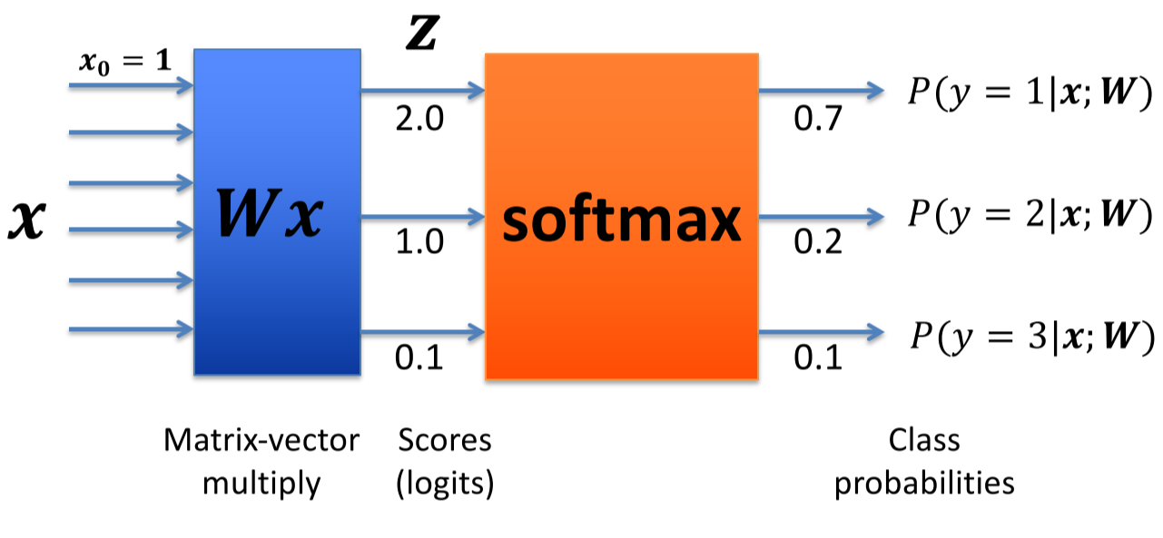

$$p=softmax(Wx)$$

* $p$ = column vector size $k$, representing categorical distribution over $k$ classes
* $x$ = column vector size $m+1$; $x_{0}=1$
* $W$ = $k×(m+1)$ weight matrix

Or, remove bias column from $W_{*,0}$:

$$p=softmax(Wx+b)$$

* $p$ = column vector size $k$, representing categorical distribution over $k$ classes
* $x$ = column vector size $m$
* $W$ = $k×m$ weight matrix
* $b$ = column vector size $k$

### Softmax Function

$$softmax{\left(z\right)}_{i}=\frac{e^{z_{i}}}{\sum_{j=1}^{k}{e^{z_{j}}}}$$

“Squashes” input $k$-dimension vector $z$ (real numbers) into a $k$-dimension vector of probabilities that add up to 1  
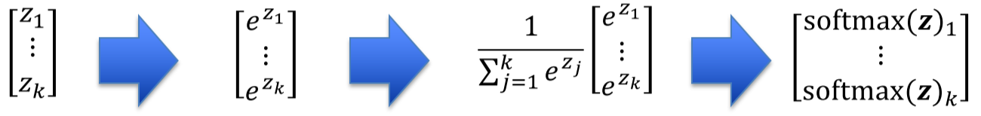

### Training Softmax Regressor

Given a dataset:

$$X=\left[\begin{matrix}1 & x_{1}^{(1)} & … & x_{m}^{(1)} \\ 1 & x_{1}^{(2)} & … & x_{m}^{(2)} \\ … & … & … & … \\ 1 & x_{1}^{(n)} & … & x_{m}^{(n)}\end{matrix}\right], y=\left[\begin{matrix}y^{\left(1\right)} \\ y^{\left(2\right)} \\ … \\ y^{\left(n\right)}\end{matrix}\right]$$

* $x^{(i)}$ is a vector
* $y^{(i)}$ is a scalar, 0 or 1

Train by minimizing cross entropy loss using **gradient descent**:

$$\hat{w}=argmin_{w}\left(\sum_{i=1}^{n}{L^{\left(i\right)}\left(w\right)}\right) \\ L^{\left(i\right)}\left(w\right)=-\ln\left(P\left(y=y^{\left(i\right)} | x^{\left(i\right)};w\right)\right) \\ P\left({y=y}^{\left(i\right)} | x^{\left(i\right)};w\right)=softmax{\left(Wx^{\left(i\right)}\right)}_{y^{(i)}}$$

### Numerically Stable Softmax

* Since exponentials can easily get very large, the Softmax function can easily overflow – this makes it numerically unstable
* To make it numerically stable, subtract the largest element of $z$ from each element of $z$ first
 $$stable_softmax{\left(z\right)}_{i}=\frac{e^{z_{i}-max⁡(z)}}{\sum_{j=1}^{k}{e^{z_{j}-max⁡(z)}}}$$

 + Why does this work?
    - Adding/subtracting a constant value from both the numerator and denominator doesn’t change the Softmax value
    - However, by subtracting $max⁡(z)$, we shift elements of $z$ towards 0 or negative
    - Exponentials with large negatives converge towards 0 instead of infinity, avoiding overflows

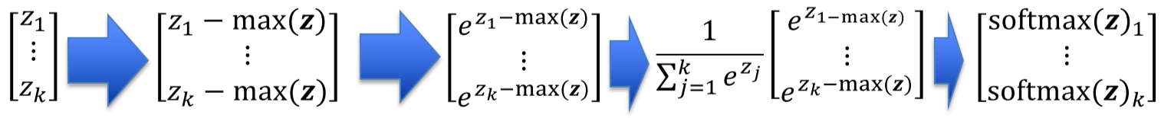

Example:

$$\left[\begin{matrix}91 \\ 90 \\ -50\end{matrix}\right]→\left[\begin{matrix}91-91=0 \\ 90-91=-1 \\ -50-91=-141\end{matrix}\right]→\left[\begin{matrix}e^{0}=1 \\ e^{-1}=0.368 \\ e^{-141}=0.000\end{matrix}\right]→\frac{1}{1.368}\left[\begin{matrix}1 \\ 0.368 \\ 0.000\end{matrix}\right]=\left[\begin{matrix}0.731 \\ 0.269 \\ 0.000\end{matrix}\right]$$

## Relationship Between Likelihood Maximization and Cross-Entropy Loss Minimization

### Maximum Likelihood Estimate (MLE)

* Cross-entropy loss is derived from the MLE of parameters

**MLE for single binary input case:**

* Likelihood of seeing a data point $\left(x^{\left(i\right)},y^{\left(i\right)}\right)$ in training data: $$P\left(y=y^{(i)} | x^{(i)};w_{0},w_{1}\right)=Ber_{y}[S(w_{1}x^{\left(i\right)}+w_{0})]$$
* Assuming each data point is identically and independently distributed, the likelihood of seeing the entire data set is the product of the likelihood of seeing each data point: $$P\left(y | x;w_{0},w_{1}\right)=\prod_{i=1}^{n}{P\left(y=y^{(i)} | x^{(i)};w_{0},w_{1}\right)}$$
* Likelihood functions are typically represented using log likelihoods (LL), since logs can be added: $$LL\left(y | x;w_{0},w_{1}\right)=\ln{P\left(y | x;w_{0},w_{1}\right)}=\ln{\prod_{i=1}^{n}{P\left(y=y^{\left(i\right)} | x^{\left(i\right)};w_{0},w_{1}\right)}} \\ =\sum_{i=1}^{n}{\ln{P\left(y=y^{\left(i\right)} | x^{\left(i\right)};w_{0},w_{1}\right)}}$$
* The MLEs of ${\hat{w}}_{0}$ and ${\hat{w}}_{1}$ are obtained by maximizing the log likelihood of seeing the entire data set: $$({\hat{w}}_{0},{\hat{w}}_{1})=argmax_{\left({\hat{w}}_{0},{\hat{w}}_{1}\right)}\left[\sum_{i=1}^{n}{\ln{P\left(y=y^{\left(i\right)} | x^{\left(i\right)};w_{0},w_{1}\right)}}\right]$$
* Since $\ln{()}$ is monotonic, maximizing log likelihood = maximizing likelihood
* We can turn log likelihood maximization into minimization of negative log: $$({\hat{w}}_{0},{\hat{w}}_{1})=argmin_{\left({\hat{w}}_{0},{\hat{w}}_{1}\right)}\left[\sum_{i=1}^{n}{-\ln{P\left(y=y^{\left(i\right)} | x^{\left(i\right)};w_{0},w_{1}\right)}}\right]$$ 
  + This is the exact equation for **minimization of cross-entropy loss**, which is the sum of losses per data point

## Cross-Entropy Loss

* **Entropy $H\left(X\right)$** is a measure of uncertainty associated with a random variable $X$
* It is defined as the expected value of the random variable $\log_{2}{\frac{1}{P\left(X\right)}},$ where $P(X)$ is the probability mass function that the variable is drawn

$$H\left(X\right)=E_{P}\log_{2}{\frac{1}{P\left(X\right)}}=\sum_{x∈X}{P(x)\log_{2}{\frac{1}{P\left(x\right)}}}$$

Since $\log\left(\frac{1}{x}\right)=-log⁡(x)$: $$H\left(X\right)=-\sum_{x∈X}{P(x)\log_{2}{P(x)}}$$

* The **surprisal** of a particular $x$ being the outcome of $X$ is $\log_{2}{\frac{1}{P\left(x\right)}}$
  + When $P\left(x\right)=1$, surprisal = 0
  + When $P\left(x\right)$ is small, surprisal is high
* Hence, the entropy of a variable is the average surprisal when sampling it

### Entropy and Bernoulli Distribution

The entropy of a Bernoulli-distributed random variable is:

$$H\left(X\right)=P\left(x=0\right)\log_{2}{\frac{1}{P(x=0)}}+P\left(x=1\right)\log_{2}{\frac{1}{P(x=1)}}$$

Example: For $Ber_{X}[0.6]$

$$H\left(X\right)=0.4\log_{2}{\frac{1}{0.4}}+0.6\log_{2}{\frac{1}{0.6}}=0.82$$

* Entropy/uncertainty is highest when a distribution is uniform

### Cross Entropy

Given an assumed distribution $Q$ over $X$ and the true distribution $P$ over $X$, the **cross entropy** between the two distributions is the average surprisal according to $Q$:

$$H_{Q}\left(P\right)=\sum_{x∈X}{P(x)\log{\frac{1}{Q\left(x\right)}}}$$

* Cross entropy measures the similarity between $P$ and $Q$
  + The cross-entropy loss of a data point is the surprisal for the true class $x$, assuming the predicted probability for that class $\log{\frac{1}{Q\left(x\right)}}$
* Cross entropy has a minimum when $P=Q$, in which case it becomes the entropy function $H(X)$

## Relationship Between Logistic and Softmax Functions

* Logistic regression uses the Bernoulli distribution with the logistic function to map scores to probabilities
 $$P\left(y|x;w\right)=Ber_{y}[S(w^{T}⋅x)]$$

 + Logistic function: $$S\left(x\right)=\frac{e^{x}}{e^{x}+1}=\frac{1}{1-e^{-x}}$$
* Softmax regression uses the Softmax function to map scores to probabilities $$P\left(y|x;W\right)=softmax{\left(z\right)}_{y}=\frac{e^{z_{y}}}{\sum_{j=1}^{k}{e^{z_{j}}}}, z=Wx$$
* Logistic regression can be formulated by Softmax by assuming $z=\left[\begin{matrix}0 \\ z\end{matrix}\right]$: $$P\left(y|x;w\right)=softmax{\left(z\right)}_{y}=\frac{e^{z_{y}}}{\sum_{j=1}^{2}{e^{z_{j}}}}=\frac{e^{z_{y}}}{e^{z_{1}}+e^{z_{2}}}=\frac{e^{z_{y}}}{1+e^{z}}=\left\{\begin{aligned}\frac{1}{1+e^{z}},y=0 \\ \frac{e^{z}}{1+e^{z}},y=1\end{aligned}\right.=Ber_{y}\left[S\left(z\right)\right]$$

### 2-Class Softmax

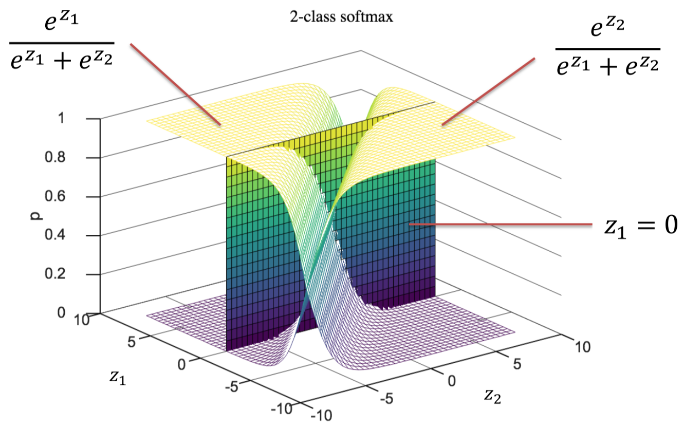

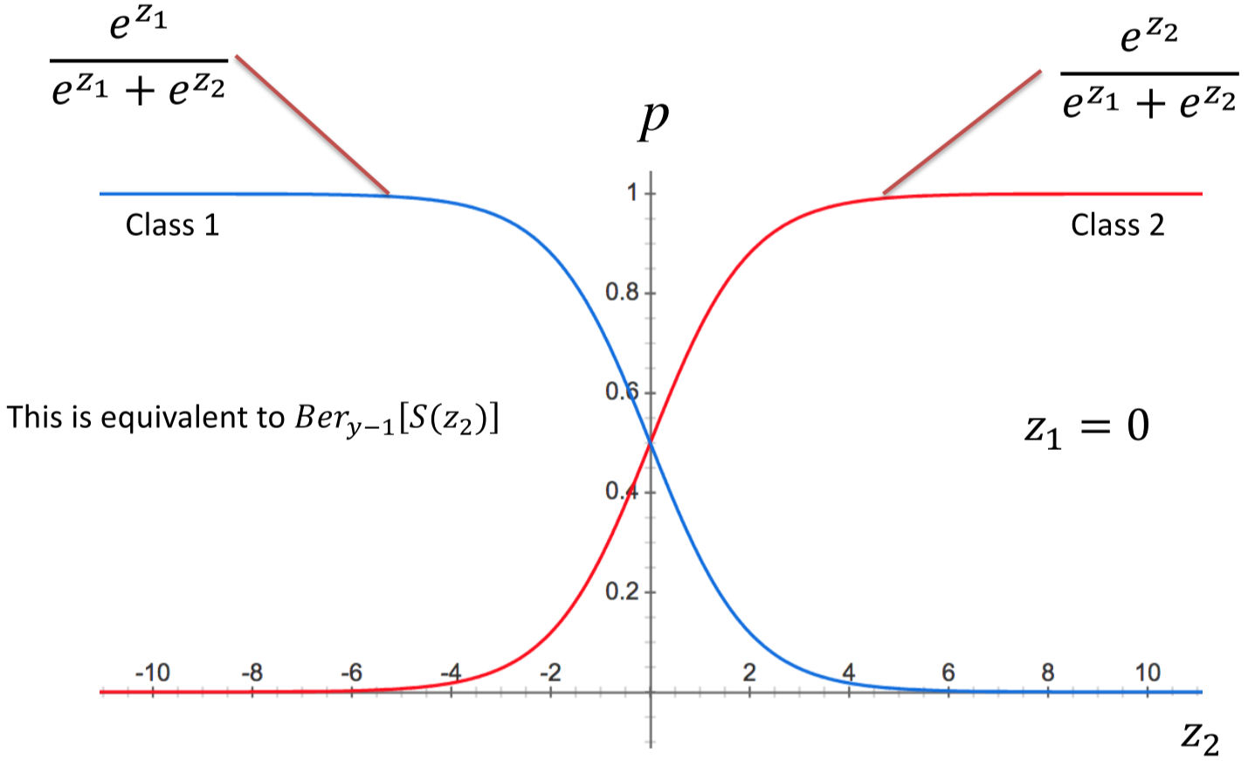

### 3-Class Softmax

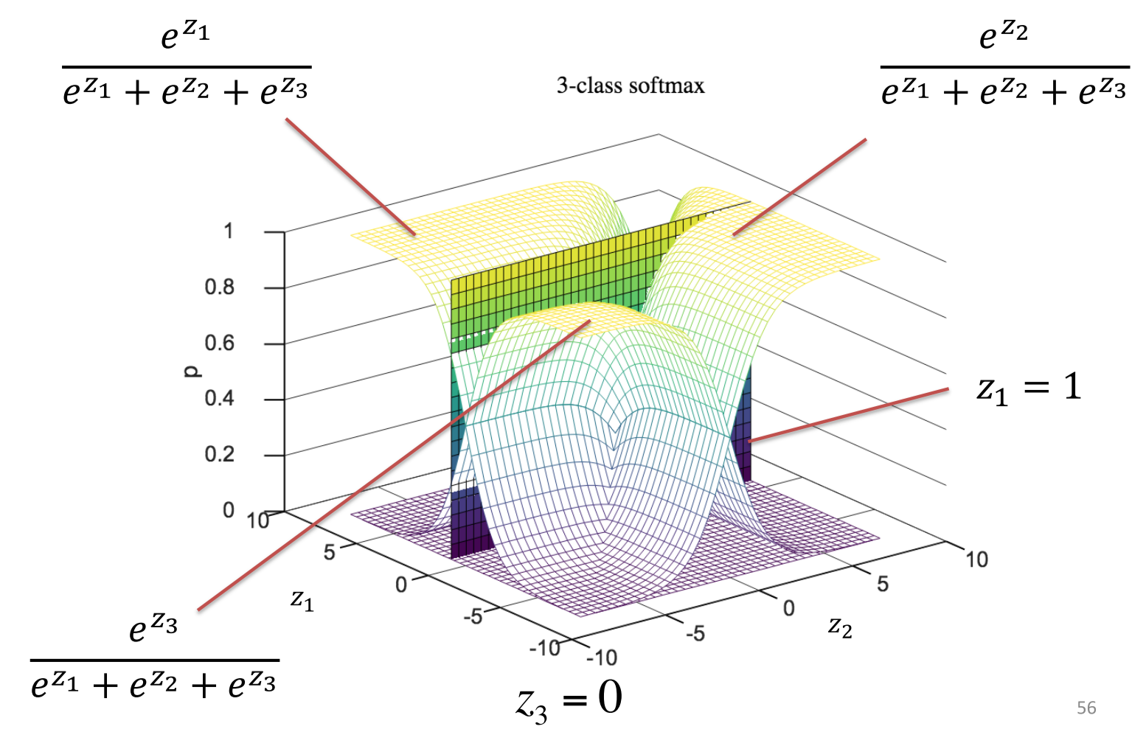

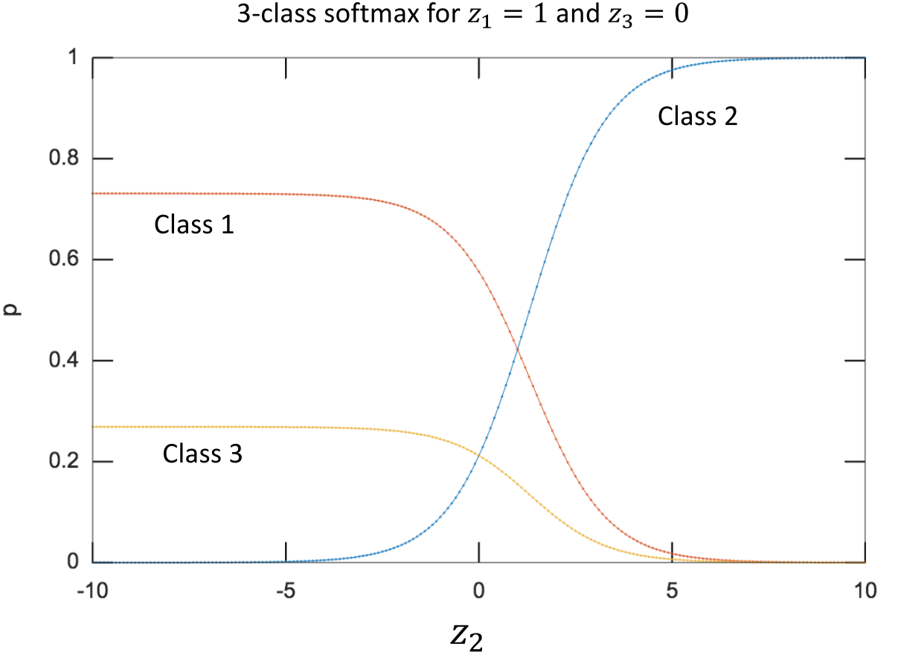

## Output Scores for Logistic/Softmax Regression

* Recall: scores are inputs into the logistic/Softmax function $$z=w^{T}x \\ P\left(y=1 | ;w\right)=S\left(z\right) \\ P\left(y=0 | ;w\right)=1-S(z)$$
* **Logit function**: inverse of the logistic function $$logit\left(p\right)=\ln\left(\frac{p}{1-p}\right)$$ 
  + Can be used to obtain scores from a probability distribution: $$z=logit\left(S\left(z\right)\right)=logit\left(P\left(y=1 | x;w\right)\right)=\ln\left(\frac{P\left(y=1 | x;w\right)}{1-P\left(y=1 | x;w\right)}\right)$$
  + Hence, the score for a class is the logit (odd’s ratio) of the class probability
* E.g. what is the logit of $p=0.7$? $$logit\left(p\right)=\ln\left(\frac{0.7}{1-0.7}\right)=0.847$$

## Relationship between Logistic and Linear Regression

* **Linear regression**: estimates the output mean for a given $x$, by minimizing sum of square errors over a data set $$\hat{y}=w^{T}x$$
* **Logistic regression**: estimates the probability of the success class for a given $x$, by minimizing the sum of surprises over a data set $$\hat{P}(y=1|x;w)=S(w^{T}x)$$

# 3-3 Machine Learning: Artificial Neural Networks

## Feedforward Neural Networks

* Neural networks that implement a **deterministic** and **parameterized** function that maps inputs $x$ to outputs $y$ $$y=f(x;θ)$$ 
  + $x$ and $y$ are vectors
  + $θ$ is the parameter set
* These functions are used as **approximators** for non-linear functions
* Given a set of input-output samples, a learning algorithm computes $θ$ such that the NN can approximate the function of interest

### Feedforward Neural Network Anatomy

A neural network is composed of an input layer + two or more layers

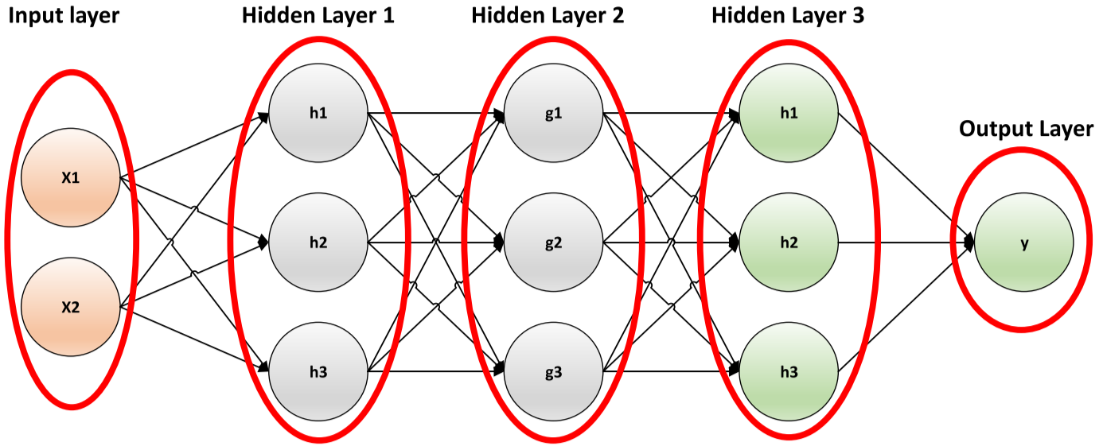

$$y=f\left(x;θ\right)=f^{\left(d\right)}\left(f^{\left(d-1\right)}\left(…f^{\left(1\right)}\left(x;θ^{\left(1\right)}\right);θ^{\left(d-1\right)}\right);θ^{\left(d\right)}\right)$$

* $d$ = network **depth**
* $x$ = **input** layer
* $f^{(d)}$ = **output** layer
* $f^{(d-1)}…f^{(1)}$ = **hidden** layers
  + Each scalar output $x_{i}, f^{(…)}$ is called a unit/neuron
  + The number of units in a layer is its width

### Types of Functions to Approximate

* **Object Classification**: image 🡪 label
* **Object Detection**: image 🡪 label + location
* **Depth Estimation**: image 🡪 depth for every pixel
* **Semantic Segmentation**: image 🡪 label for every pixel

## Training

* Give neural network examples of an output function $f^{*}(x)$ for a wide variation of $x$
* Optimize parameters $θ$ to force $f(x;θ)≅f^{*}(x)$
* Training data: pairs of $x, f^{*}(x)$
  + Only the output is specified by the training data – the NN is free to do whatever it wants in the hidden layers

## Hidden Layers

$$h^{\left(n\right)}=g\left(Wh^{\left(n-1\right)}+b\right)$$

* $g$ = activation function
* $h^{\left(n-1\right)}$ = input
* $W$ = weight matrix
* $b$ = bias
* $θ$ parameters are the weights and biases of all the layers in the network

## Rectified Linear Unit (ReLU)

The ReLU hidden unit is currently the default activation function of feedforward neural networks $$g\left(z\right)=max⁡(0,z)$$

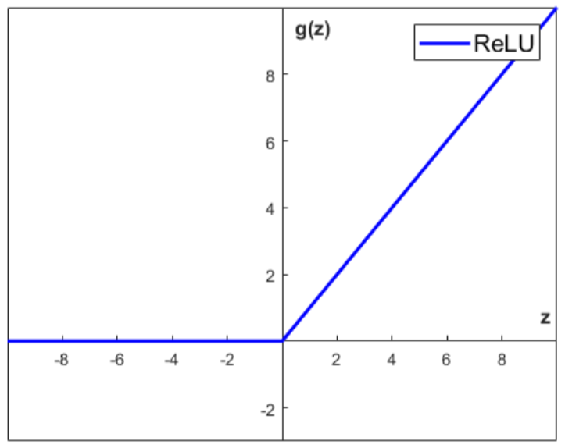

Example:

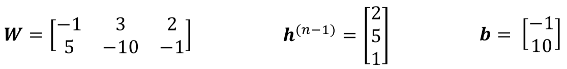

$$h\left(n\right)=g(Wh^{\left(n-1\right)}+b)$$

$$Wh^{\left(n-1\right)}+b=\left[\begin{matrix}-1 & 3 & 2 \\ 5 & -10 & -1\end{matrix}\right]×\left[\begin{matrix}2 \\ 5 \\ 1\end{matrix}\right]+\left[\begin{matrix}-1 \\ 10\end{matrix}\right]=\left[\begin{matrix}\left(-1×2+3×5+2×1\right)-1 \\ (5×2-10×5-1×1)+10\end{matrix}\right]=\left[\begin{matrix}14 \\ -31\end{matrix}\right]$$

$$h\left(n\right)=g\left(Wh^{\left(n-1\right)}+b\right)=\max\left(0, \left(Wh^{\left(n-1\right)}+b\right)\right)=\left[\begin{matrix}14 \\ 0\end{matrix}\right]$$

## Artificial Neural Networks

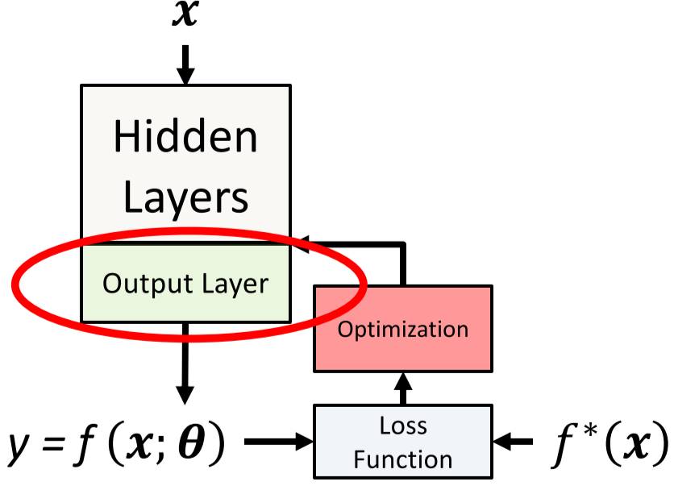

* To build a ML model, you need:
  + Model
  + Loss function
  + Optimization procedure

### Supervised Learning Tasks

* **Classification**: map input $x$ to one of $k$ classes
* **Regression**: map input $x$ to a real number

## Classification: Softmax Output Layer

* Softmax output layers are most often used as the output of a classifier, to represent the **probability distribution** over $k$ different classes
* A Softmax output layer consists of:
  1. Linear transformation $z=Wh+b$
  2. Softmax function: $softmax{\left(z\right)}_{i}=\frac{e^{z_{i}}}{\sum_{j}{e^{z_{j}}}}$

Example:

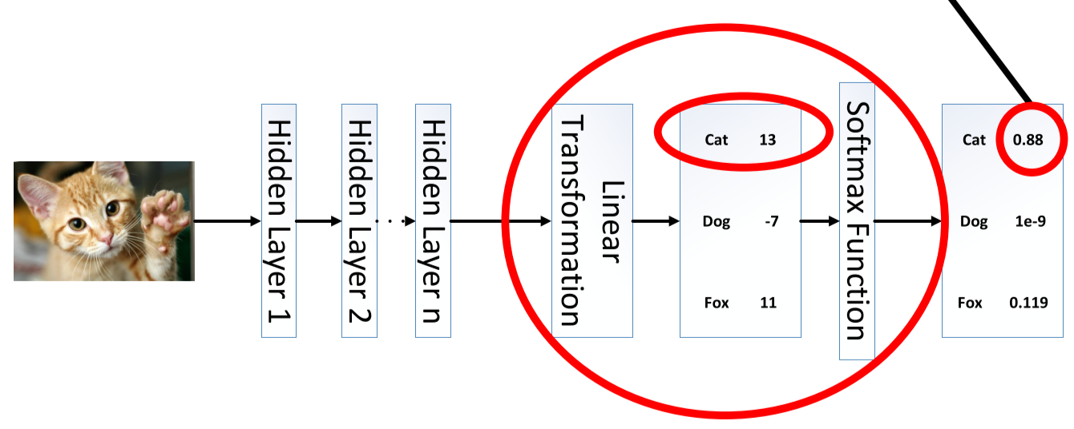

$$softmax{\left(z\right)}_{Cat}=\frac{e^{13}}{e^{13}+e^{-7}+e^{11}}=0.88$$

## Classification: Cross-Entropy Loss Function

* If we consider that the output of the Softmax layer is a probability distribution, the cross-entropy loss function is derived using maximum likelihood: $$L\left(θ\right)=-\log\left(softmax{\left(z\right)}_{i}\right)=-z_{i}+\log\left(\sum_{j}{e^{z_{j}}}\right)$$

Example: Cat example above

$$L\left(θ\right)=-13+\log\left(e^{13}+e^{-7}+e^{11}\right)=0.127$$

## Regression: Linear Output Layers

* **Linear output units** are based on an affine transformation with no non-linearity
* They are usually used with the **Mean Squared Error** loss function to model the mean of a probability distribution: $$L{\left(θ\right)}^{(n)}=\sum_{i}{{\left(z_{i}-f{\left(x^{\left(n\right)}\right)}_{i}^{*}\right)}^{2}}$$

Total loss: $L\left(θ\right)=\frac{1}{N}\sum_{n}{L{\left(θ\right)}^{\left(n\right)}}$

# 4-1 Machine Learning: Training Neural Networks

## Neural Network Loss Functions

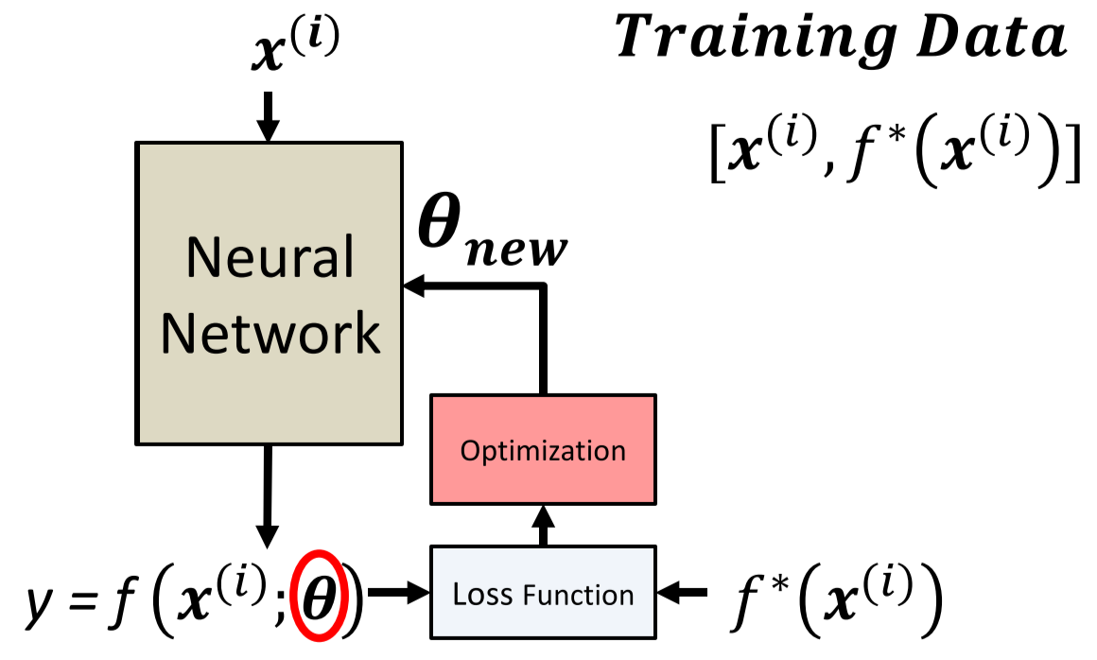

* Thousands of training data pairs: $[x^{\left(i\right)}, f^{*}\left(x^{\left(i\right)}\right)]$
* **Training loss**: the loss function computed over all $N$ training samples $$J\left(θ\right)=\frac{1}{N}\sum_{i=1}^{N}{L[f\left(x^{\left(i\right)},θ\right), f^{*}\left(x^{\left(i\right)}\right)]}$$
* The **gradient** of the training loss with respect to the parameters $θ$ is:

$$∇_{θ}J\left(θ\right)=∇_{θ}\left[\frac{1}{N}\sum_{i=1}^{N}{L\left[f\left(x^{\left(i\right)},θ\right), f^{*}\left(x^{\left(i\right)}\right)\right]}\right]=\frac{1}{N}\sum_{i=1}^{N}{∇_{θ}L[f\left(x^{\left(i\right)},θ\right), f^{*}\left(x^{\left(i\right)}\right)]}$$

## Computing Loss Gradient

### Gradient Computation Methods

1. **Numerical gradient** – approximate $\frac{∆L}{∆w_{j}}$, for small $∆w_{j}$

* Inaccurate and slow

1. **Symbolic gradient** – closed-form formula
   * Exact, and can be symbolically manipulated & optimized
   * Would result in huge formulas for large networks
2. **Automatic differentiation** – middle ground between 1 and 2
   * Precise and efficient
   * Forward and backward mode
     + Forward mode is more efficient when more outputs than inputs
     + Backward mode is called **backpropagation**

* During training, use backpropagation for efficient gradient computation
* Numerical gradient is used for test correctness when implementing automatic differentiation

## Backpropagation

Given a function $f(x,y,z)=\left(x+y\right)z$

* Can be broken into two functions: $q=(x+y)$, $f=qz$
* Chain rule: $\frac{∂f}{∂x}=\frac{∂f}{∂q}\frac{∂q}{∂x}$
$\frac{∂f}{∂q}=z$

$\frac{∂q}{∂x}=1$

$\frac{∂q}{∂y}=1$

* Hence: $\frac{∂f}{∂x}=$ $\frac{∂f}{∂y}=1×z=z$
* $\left[\frac{∂f}{∂x},\frac{∂f}{∂y},\frac{∂f}{∂z}\right]$ tell us the sensitivity of $x,y,z$ on $f$

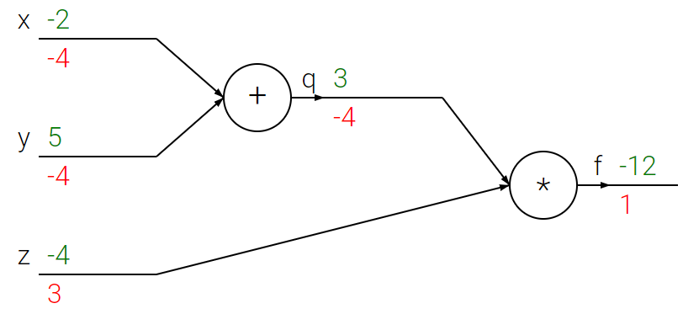

* Forward pass: computes values from inputs to output
* Backwards pass: computes backpropagation, which starts at output and recursively applies the chain rule to compute the gradients

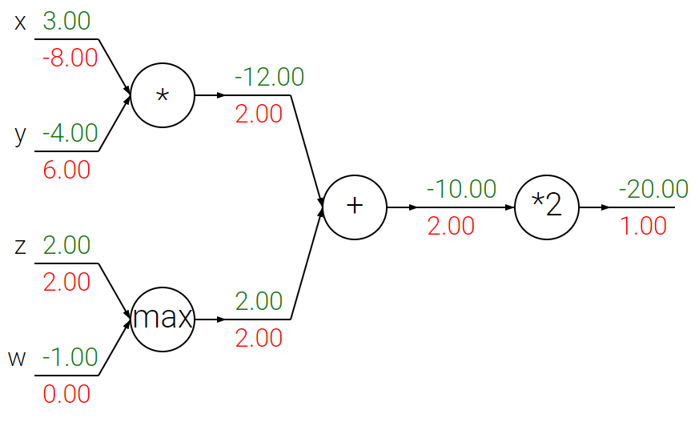

* **Sum operations**: distributes gradients equally to inputs (maintain same gradient)
* **Multiply operations**: multiplies gradient by the other (swapped) input
* **Max operations**: routes gradient to higher input, other one is 0

Example:

x **=** 3 *# example values*

y **=** **-**4

*# forward pass*

sigy **=** 1.0 **/** (1 **+** math**.**exp(**-**y)) *# sigmoid in numerator #(1)*

num **=** x **+** sigy *# numerator #(2)*

sigx **=** 1.0 **/** (1 **+** math**.**exp(**-**x)) *# sigmoid in denominator #(3)*

xpy **=** x **+** y *#(4)*

xpysqr **=** xpy**\*\***2 *#(5)*

den **=** sigx **+** xpysqr *# denominator #(6)*

invden **=** 1.0 **/** den *#(7)*

f **=** num **\*** invden *# done! #(8)*

Applying backpropagation:

*# backprop f = num * invden*

df_dnum **=** invden *# gradient on numerator #(8)*

df_dinvden **=** num *#(8)*

*# backprop invden = 1.0 / den*

df_dden **=** -den**(-2) * df_dinvden  *#(7)*

*# backprop den = sigx + xpysqr*

df_dsigx **=** 1 * df_dden  *#(6)*

df_dxpysqr **=** 1 * df_dden  *#(6)*

*# backprop xpysqr = xpy**2*

df_dxpy **=** 2 * xpy * df_dxpysqr  *#(5)*

*# backprop xpy = x + y*

df_dx **=** 1 * df_dxpy  *#(4)*

df_dy **=** 1 * df_dxpy  *#(4)*

*# backprop sigx = 1.0 / (1 + math.exp(-x))*

df_dx +**=** ((1 **-** sigx) **\*** sigx) **\*** df_dsigx  *#(3)*

*# backprop num = x + sigy*

df_dx +**=** 1 **\*** df_dnum  *#(2)*

df_dsigy **=** 1 **\*** df_dnum  *#(2)*

*# backprop sigy = 1.0 / (1 + math.exp(-y))*

df_dy +**=** ((1 **-** sigy) **\*** sigy) **\*** df_dsigy  *#(1)*

* **Cache forward pass variables**: to compute the backward pass, it is very helpful to have some of the variables that were used in the forward pass
* **Gradients add up at forks**: The forward expression involves the variables x and y multiple times, so when we perform backpropagation, we must be careful to use += to accumulate the gradient on these variables

## Batch Gradient Descent

* Iterative first-order optimization procedure
* Algorithm:
  + Initialize parameters $θ$
  + While stopping condition isn’t met:
    - Compute gradient of loss function over all training examples: $$∇_{θ}J(θ)=\frac{1}{N}\sum_{i=1}^{N}{∇_{θ}L[f\left(x^{\left(i\right)},θ\right), f^{*}\left(x^{\left(i\right)}\right)]}$$
    - Update parameters: $$θ=θ-ε∇_{θ}J(θ)$$

### Parameter Initialization and Stopping Conditions

* **Initialization**:
  + Weights: randomly sample from normal distribution
  + Biases: 0
  + Other heuristics exist
* **Stopping conditions**:
  + Number of training iterations
  + Change in $θ$ value: stop if $θ_{new}-θ_{old}>threshold$
  + Change in $J\left(θ\right)$ value: stop if $J\left(θ_{new}\right)-J\left(θ_{old}\right)>threshold$
* Using backpropagation to compute $∇_{θ}J(θ)$ is very expensive for the entire training set
* $∇_{θ}J(θ)$ is a **mean**
  + Standard error of the mean estimated from $N$ samples is $\frac{σ}{\sqrt{N}},$ where $σ$ is the standard deviation of the value of the samples
  + Using all samples to estimate the mean results in less than linear accuracy
  + Hence, use a small sample (**minibatch**) of the training data to estimate the gradient

## Stochastic (Minibatch) Gradient Descent (SGD)

Algorithm:

* Initialize parameters $θ$
* While stopping condition isn’t met:
  + Sample $N'$ (pre-set number) of examples from the training data
  + Compute gradient of loss function over all training examples: $$∇_{θ}J(θ)=\frac{1}{N'}\sum_{i=1}^{N'}{∇_{θ}L[f\left(x^{\left(i\right)},θ\right), f^{*}\left(x^{\left(i\right)}\right)]}$$
  + Update parameters: $$θ=θ-ε∇_{θ}J(θ)$$

What minibatch size to use?

* GPUs work better with **powers of 2** batch sizes
* Large batch sizes (> 256):
  + Hardware underutilized with very small batch sizes
  + More accurate estimate, but with less than linear returns
* Small batch sizes (< 64):
  + Allows for faster convergence, since algorithm can compute parameters faster
  + Offer **regularizing effect** – best generalization error is often achieved with batch size = 1
* Always make sure dataset is **shuffled** before sampling minibatch

### SGD Variations

* **ADAM**: implemented in most neural network libraries, fairly robust to choice of learning rate and other hyper parameters

## Data Splits

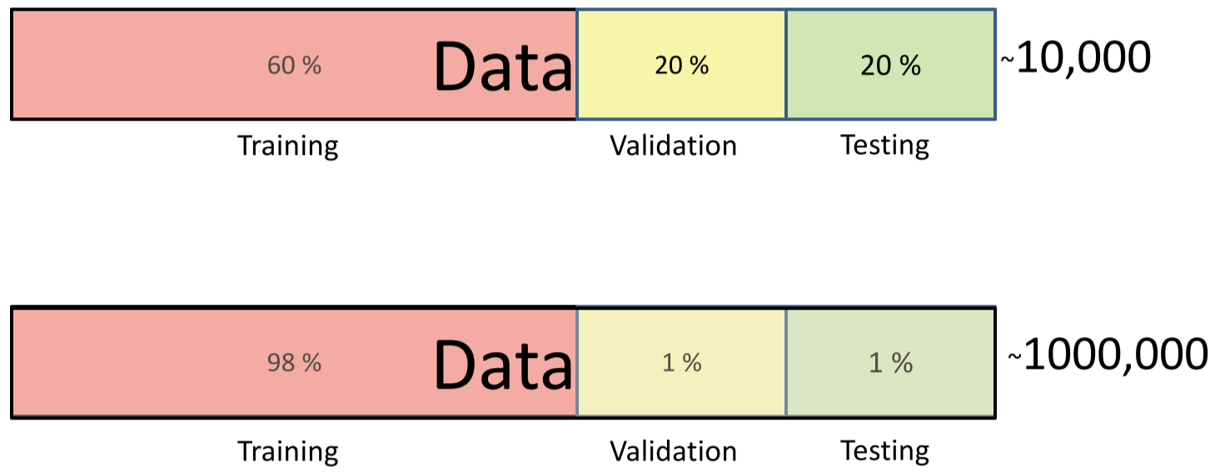

* **Training split**: minimize loss function
* **Validation split**: used to choose hyperparameters, such as learning rate, number of layers, etc.
* **Test split**: the neural network never observes this set during design process

### Behaviour of Split-Specific Loss Functions

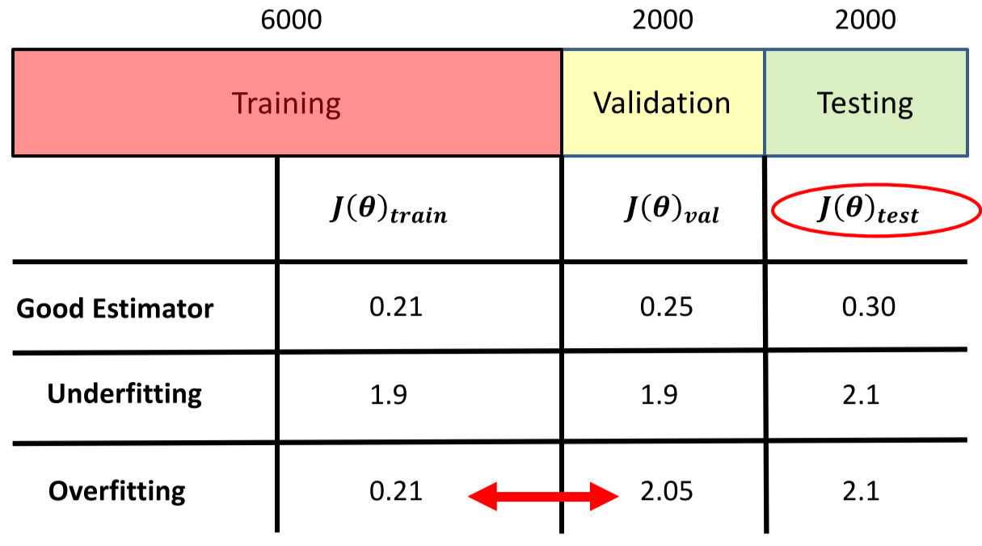

* **Good estimator**: training and validation loss both low
* **Underfitting**: training losshigh
* **Overfitting**: large gap between training loss and validation loss

### Reducing the Effect of Underfitting/Overfitting

* Fix underfitting:
  + Train longer
  + Add more layers, or more parameters per layer
  + Change architecture
* Fix overfitting:
  + More training data
  + Regularization
  + Change architecture

## Regularization

* Adds cost to model complexity
* Use regularization methods to prevent network from overfitting
  + Suppose a set of weights $W$ correctly classifies every example
  + Problem: $W$ is not necessarily unique – there may be similar $W$ that correctly classifies all the examples
  + Fix: if $W$ correctly classifies all examples, any multiple of $W$ should do the same

### Parameter Norm Penalties

$$J{\left(θ\right)}_{reg}=J\left(θ\right)+αΩ(W)$$

* $α$ = hyperparameter that weighs the relative contribution of the norm penalty to the loss function value
* $Ω(W)$ = measure of how large $θ$’s value is; it is usually a **Lp norm**
* Usually only constrain size of weights, not biases

### L2 Norm Parameter Penalty

$$Ω\left(W\right)=\frac{1}{2}W^{T}W=\frac{1}{2}{\left\|W\right\|}^{2}$$

* Heavily penalizes large weight vectors, preferring diffuse weight vectors
* Use factor $\frac{1}{2}$ so that the gradient with respect to $W$ is simply $αW$ instead of $2αW$

### Dropout

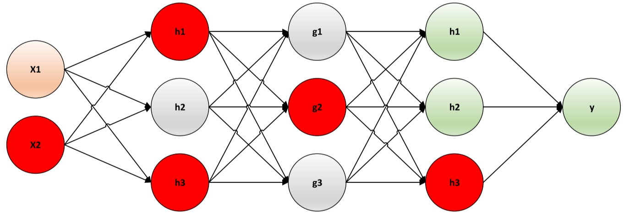🡪 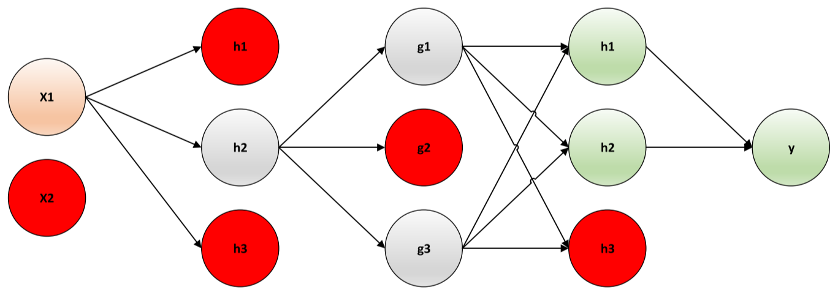

* Multiple weights $W$ by $P_{keep}$ at the end of training
  + Neuron is kept active by probability $P_{keep}$, set to 0 otherwise
* Computationally inexpensive but powerful regularization method
* Doesn’t significantly limit the type of model/training used

### Early Stopping

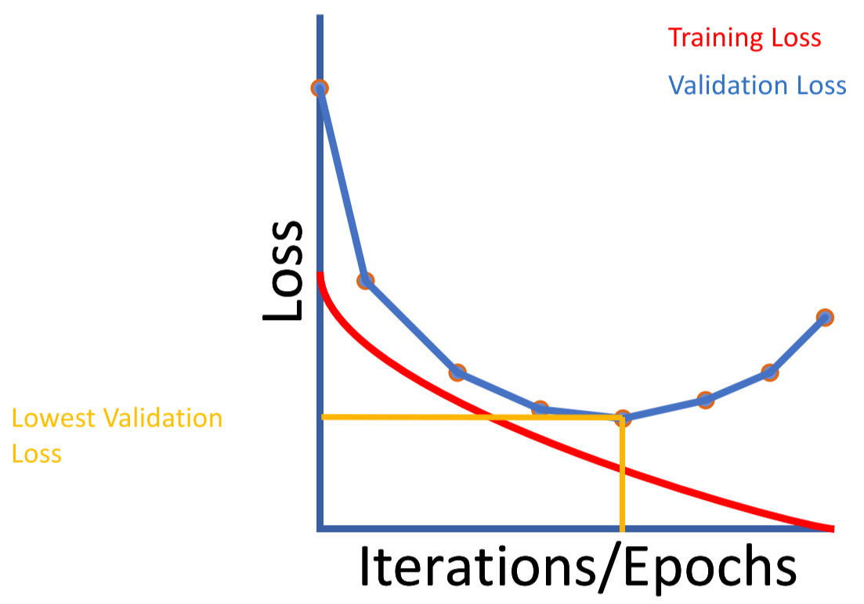



# 4-2 Deep Learning: Convolutional Neural Networks

## ConvNets

* Processes data defined on a grid
* 1D time series data, 2D images, 3D videos
* Two major types of layers:
  + **Convolution** layers
  + **Pooling** layers

## Fully Connected vs. Convolutional Layers

**Fully connected layers**: $h^{\left(n\right)}=g\left(Wh^{\left(n-1\right)}+b\right)$

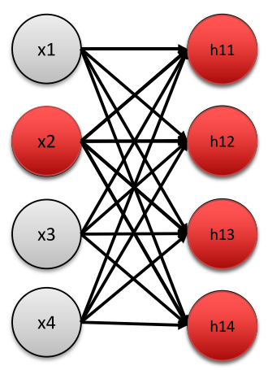

**Convolutional layers**: $h^{\left(n\right)}=g\left(W*h^{\left(n-1\right)}+b\right)$

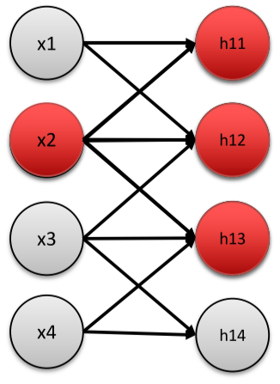

* **Receptive field**: the inputs that a neuron connects to (local region)
  + It is impractical to connect neurons to all neurons
  + Extent of connectivity = depth of input volume
* Example: Suppose that the input volume has size [32x32x3] and the receptive field (or the filter size) is 5x5.
  + Each neuron in the Conv Layer will have weights to a [5x5x3] region in the input volume, for a total of 5*5*3 = 75 weights (and +1 bias parameter)
* Example: Suppose that the input volume has size [16x16x20] and the receptive field (or the filter size) is 3x3.
  + Each neuron in the Conv Layer will have weights to a [3x3x20] region in the input volume, for a total of 3*3*20 = 180 weights

## Cross-Correlation

* Each filter is spatially small but extends the full depth of the input volume
  + **Width**: width of input volume
  + **Height**: height of input volume
  + **Depth**: number of channels of input volume
  + **Padding size**: essential to retain input shape
* During the forward pass, convolve (slide) filter across width and height of input volume, computing element-wise products between the filter and input entries at every position
  + **Stride**: the number of pixels the filter is moved each time
  + This produces a 2D activation map that gives the responses of the filter at every position
  + The network will learn filters that activate when they see some type of visual feature
* Each convolution layer has a set of filters, with each of them producing a separate 2D activation map
* The activation maps are stacked along the depth to produce the output volume

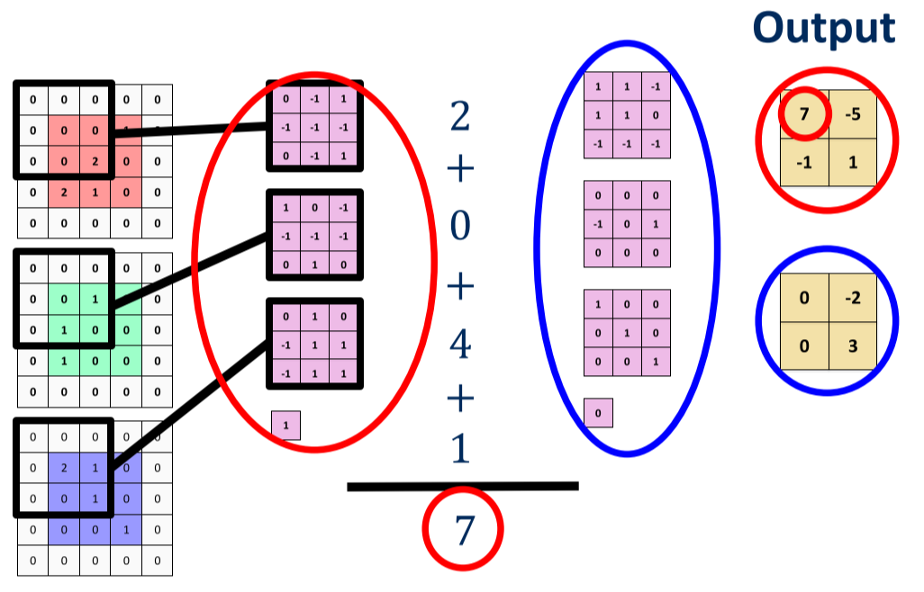

$$\left(0⋅0+0⋅-1+0⋅0+0⋅-1+0⋅-1+0⋅-1+0⋅1+0⋅-1+2⋅1\right)=2$$

$$\left(0⋅1+0⋅-1+0⋅0+0⋅0+0⋅-1+1⋅1+0⋅-1+1⋅-1+0⋅0\right)=0$$

$$\left(0⋅1+0⋅-1+0⋅-1+0⋅1+2⋅1+0⋅1+0⋅0+1⋅1+1⋅1\right)=4$$

$$2+0+4+1\left(bias\right)=7$$

### Output Volume Shape

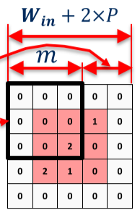



Given filter size $m×m$, number of filters $K$, stride $S$, and padding $P$:



$$W_{out}=\frac{W_{in}+2×P-m}{S}+1$$

$$H_{out}=\frac{H_{in}+2×P-m}{S}+1$$

$$D_{out}=K$$

## Pooling Layers: Max Pooling

Downsamples the output to reduce size of input to next layer

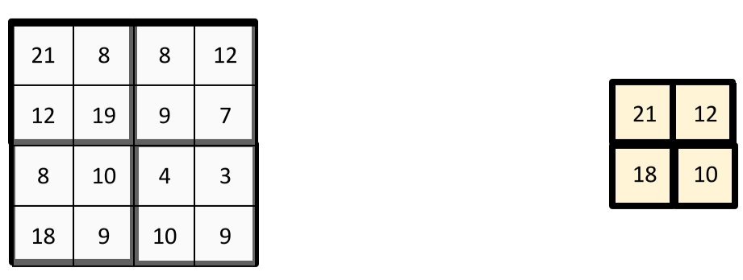

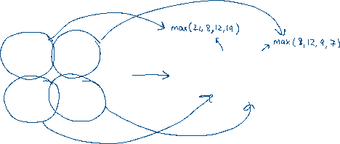

### Output Volume Shape

Given pool size $m×m$ and stride $S$:

$$W_{out}=\frac{W_{in}-m}{S}+1$$

$$H_{out}=\frac{H_{in}-m}{S}+1$$

$$D_{out}=D_{in}$$

Example above:

$$W_{out}=H_{out}=\frac{4-2}{2}+1=2$$

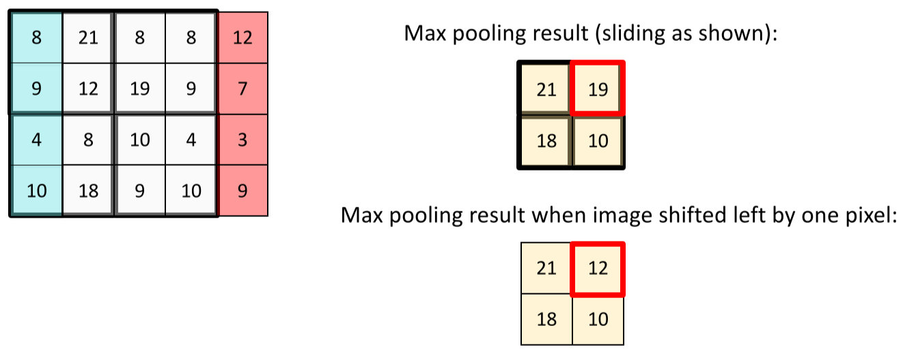

Result is almost the same – **translation invariance**

## Advantages of ConvNets

* Convolution layers have fewer parameters than fully-connected layers, thus **reducing the chance of overfitting**
* Convolution layers use the same parameters to process every block of the image – this makes it **translation invariant**, which is important for understanding images

## Image Feature Extraction using ConvNets

Input image 🡪 Feature Extractor 🡪 Task-Specific Layers 🡪 Output

* Feature extractors are the most computationally expensive part of the object detector
* The output usually has much lower width and height than the input image, but much greater depth
* Most common extractors: VGG, ResNet, and Inception

### VGG Feature Extractor

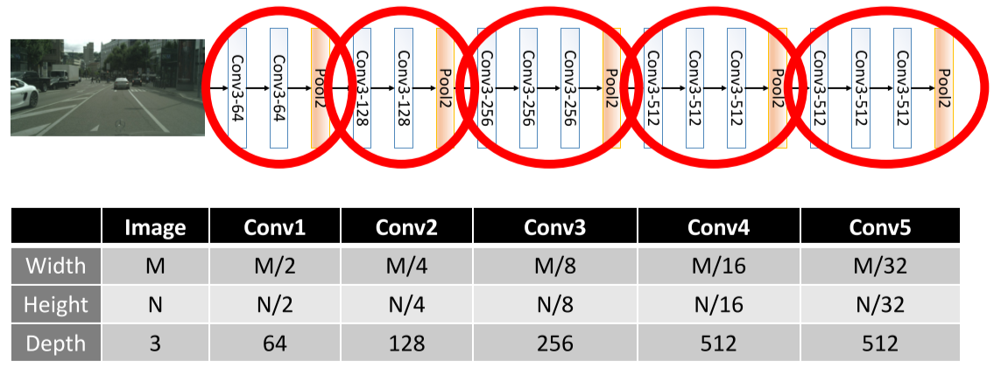

* Alternating convolutional and max pooling layers
* All convolutional layers are size $3×3×K$, with stride $S=1$ and zero-padding $P=1$

$$W_{out}=\frac{W_{in}+2×1-3}{1}+1=W_{in} \\ H_{out}=\frac{H_{in}+2×1-3}{1}+1=H_{in} \\ D_{out}=K$$

All max pooling layers are size $2×2$, with stride $S=2$ and no padding $$W_{out}=\frac{W_{in}-2}{2}+1=\frac{W_{in}}{2}$$

$$H_{out}=\frac{H_{in}-2}{2}+1=\frac{H_{in}}{2}$$

$$D_{out}=D_{in}$$

## What Features Does the Feature Extractor Learn?

* **First layer**: visualize filters
* **Intermediate layers**: activation analysis
  + Maximally activate patches
  + Guided backpropagation
  + Pixels of specific input image activate a given neuron determined using gradient ascent
* **Last layer**: visualize feature space

# 4-3 Deep Learning: Semantic Segmentation

## The Semantic Segmentation Problem

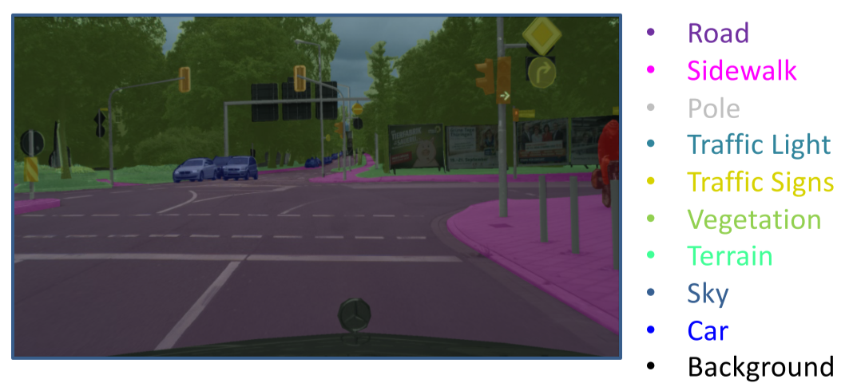

**Goal**: provide a class label for every pixel in the input image

Input image 🡪

* Semantic segmentation can be hindered by occlusion, truncation, scale, and illumination changes
* Desire smooth boundaries between segments

### Evaluation Metrics

For a given class X:

* **True Positive (TP)**: pixel classified correctly as X
* **False Positive (FP)**: pixel classified incorrectly as X
* **True Negative (TN)**: pixel classified correctly as not X
* **False Negative (FN)**: pixel classified incorrectly as not X

### Pixel Accuracy

The percentage of pixels identified correctly:

$$Accuracy=\frac{\#TP+\#TN}{\#TP+\#FP+\#TN+\#FN}$$

* Can be computed per class or globally
* Can lead to misleading results, as it doesn’t account for the size of a class
  + Bias towards negative case in underrepresented/small classes
  + Bias towards positive case leads to high accuracy of overrepresented classes

## Intersection over Union

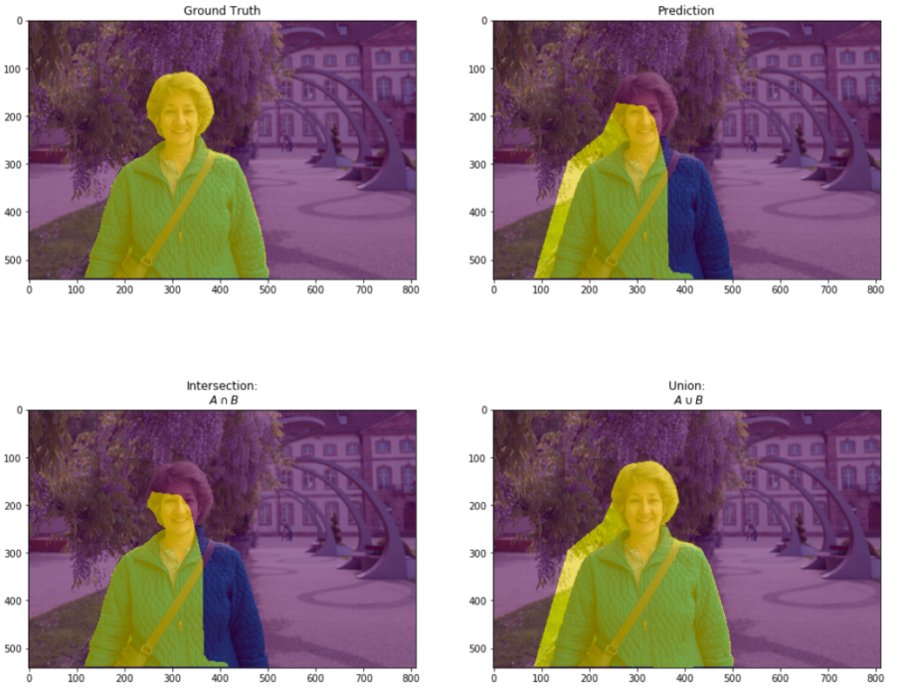

Better method of determining accuracy

$$IOU_{class}=\frac{Intersection}{Union}=\frac{\#TP}{\#TP+\#FP+\#FN}$$

* Disregards True Negatives

Example:

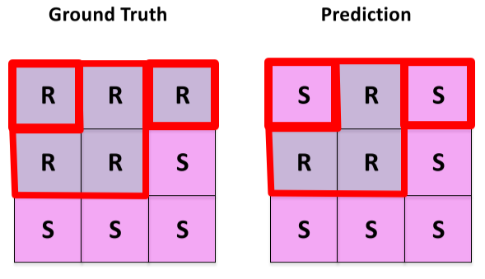



Class: Road

$$\#TP=3 \\ \#FP=0 \\ \#FN=2$$

$$IOU_{Road}=\frac{3}{3+0+2}=\frac{3}{5}$$

Class: Sidewalk

$$\#TP=4 \\ \#FP=2 \\ \#FN=0$$

$$IOU_{Sidewalk}=\frac{4}{4+2+0}=\frac{2}{3}$$

### Evaluation Metrics

* **Class IOU** over all of the datais found by computing the sum of $\#TP, \#FP, \#FN$ for all images first
  + Averaging the class IOU over images is usually not a good idea
* **mIOU** is the mean IOU, computed as a mean of class IOUs over all classes

## ConvNets for Semantic Segmentation

### Upsampling Layer

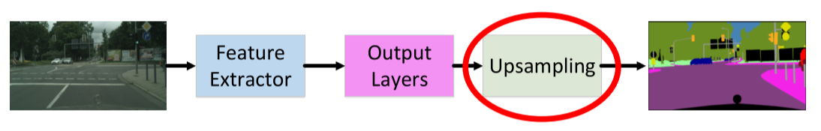

Upsampling multiplier = $S$

$W_{out}=S×W_{in}$

$H_{out}=S×H_{in}$

$D_{out}=D_{in}$

**Nearest Neighbour Upsampling**

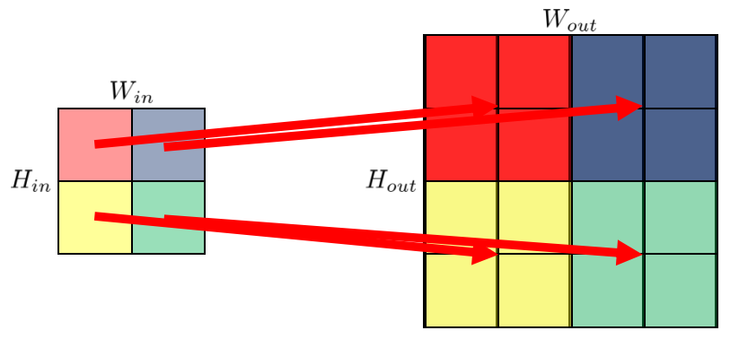

* Really bad resolution when upsampled

## Learning Same Resolution Feature Maps

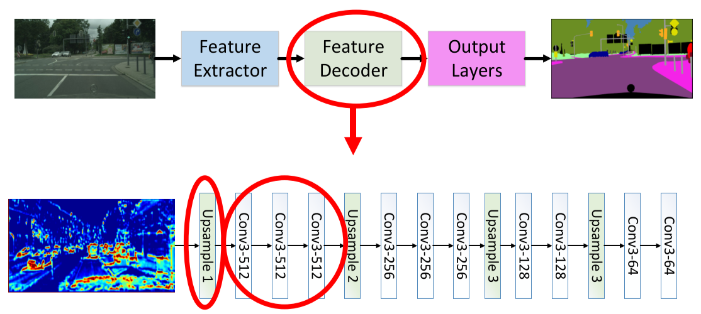 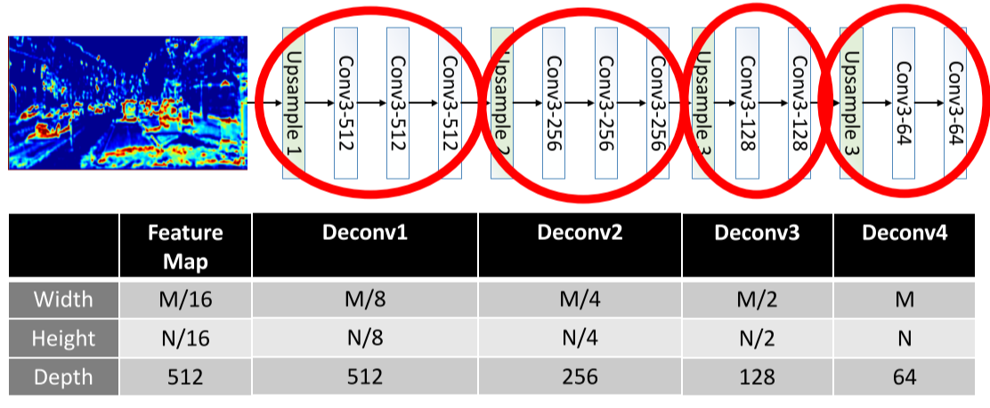

Output layer 🡪 Softmax layer

### Classification Loss

$$L_{class}=\frac{1}{N_{total}}\sum_{i}{CrossEntropy\left(s_{i},s_{i}^{*}\right)}$$

* $N_{total}$ = number of pixels in all minibatch images
* $s_{i}$ = neural network output
* $s_{i}^{*}$ = ground truth classification

### PSPNet Architecture

**Feature pyramid** provides multiple scales at every location, thus enhancing context

### Dilation/Atrous Convolutions

**Increase receptive field** to capture large objects without increasing number of parameters

* Dilation rate $n$ = take every $n^{th}$ pixel

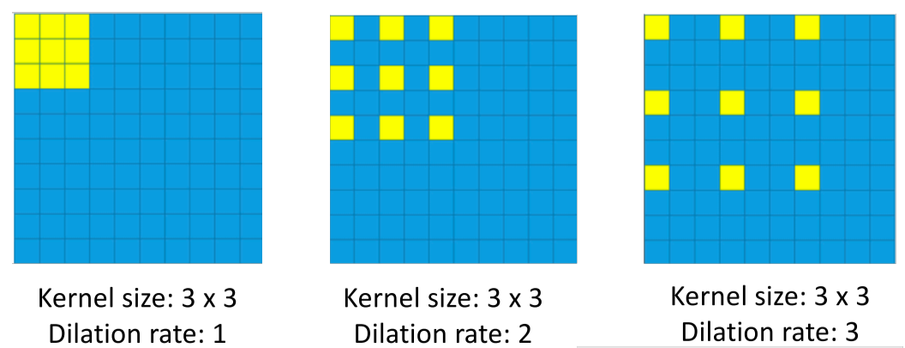

# 5-1 Deep Learning: 2D Object Detection

## The Object Detection Problem

Mapping input images to label + location

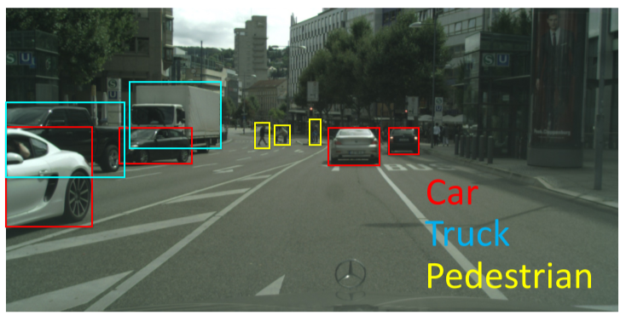

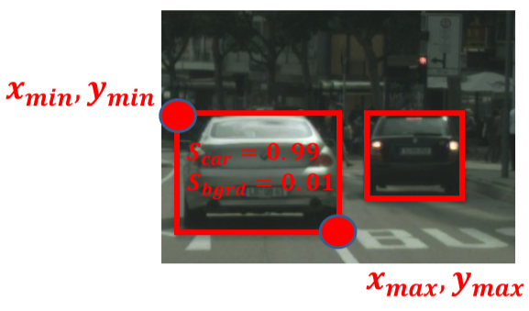

Input image 🡪

* Extents of objects may not be fully observed:
  + **Occlusion** – background objects covered by foreground objects
  + **Truncation** – objects out of image boundaries
* **Scale**: objects get smaller as objects are further away
* **Illumination changes**: lighting is too bright or too dark

## ConvNets for Object Detection

### Evaluation Metrics

* **Intersection over Union (IOU)**: intersect area of predicted box with provided ground truth box, divided by their union  
  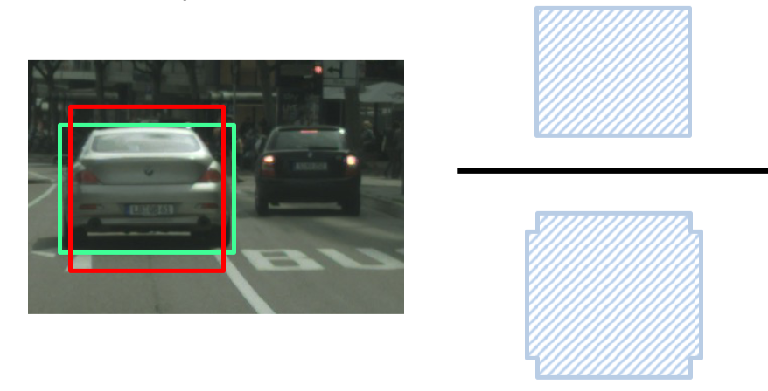
* **True Positive (TP)**: object class score $≥$ score threshold, IOU $≥$ IOU threshold
* **False Positive (FP)**: object class score $≥$ score threshold, IOU $<$ IOU threshold
  + Correct label but wrong location
* **False Negative (FN)**: ground truth object not detected by algorithm
* **Precision**: $$Precision=\frac{\#TP}{\#TP+\#FP}$$
* **Recall**: $$Recall=\frac{\#TP}{\#TP+\#FN}$$
* **Precision Recall (PR) Curve**: use multiple object class score thresholds to compute precision and recall; plot precision values on x-axis and recall values on y-axis
* **Average Precision**: area under PR-Curve for a single class
  + Usually approximated using **11** recall points

Example: Score threshold = 0.9, IOU threshold = 0.7

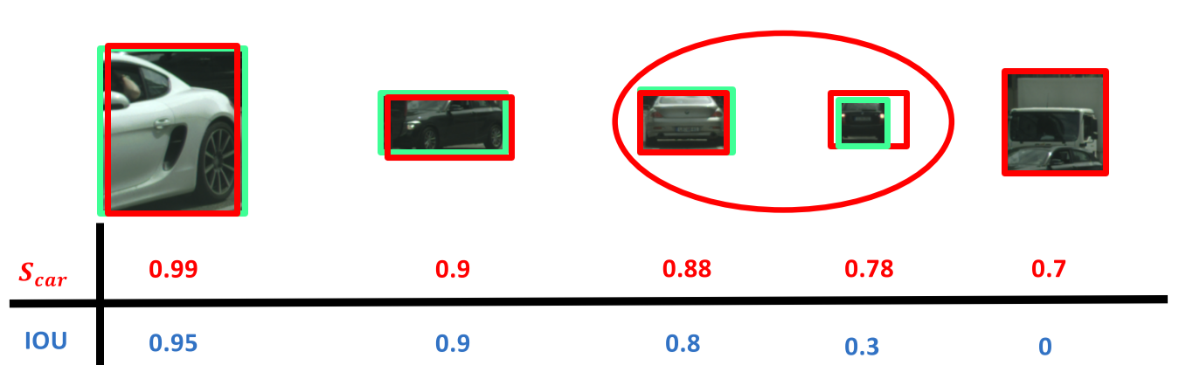

$$\#TP=2 \\ \#FP=0 \\ \#FN=2$$

$$Precision=\frac{2}{2+0}=1$$

$$Recall=\frac{2}{2+2}=\frac{1}{2}$$

Example: Score threshold = 0.7, IOU threshold = 0.7  
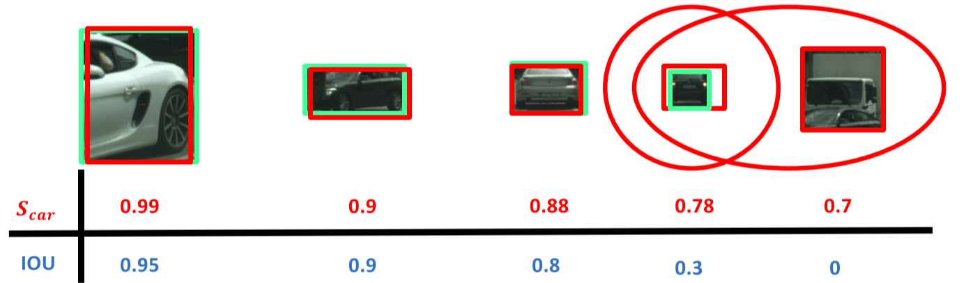

$$\#TP=3 \\ \#FP=2 \\ \#FN=1$$

$$Precision=\frac{3}{3+2}=\frac{3}{5}$$

$$Recall=\frac{3}{3+1}=\frac{3}{4}$$

Example:

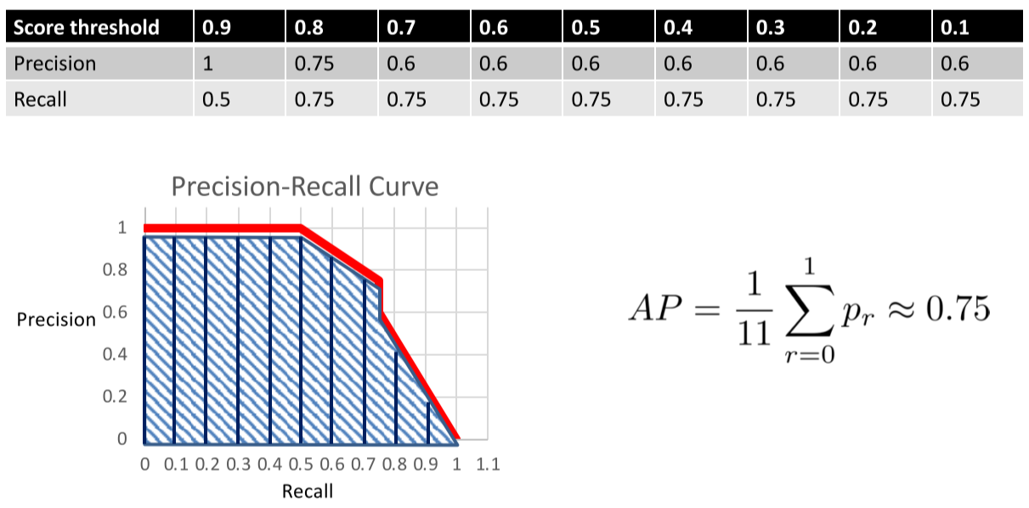

$$AP=\frac{1}{11}\left(1+1+1+1+1+1+0.85+0.76+0.4+0.2+0\right)=0.746$$

## AP Calculation – Precise Procedure

1. Sort all predictions by score (Softmax probability) in descending order
   * Sort predictions with same score by IOU in descending order
2. Calculate precision and recall for each rank
3. Plot the PR curve
4. Apply monotone interpolation (smooth the line)
5. Take precision samples at 11 points: 0, 0.1, … 0.9, 1 of recall
6. Calculate average of 11 points



Example: Small test set with 5 cars in ground truth

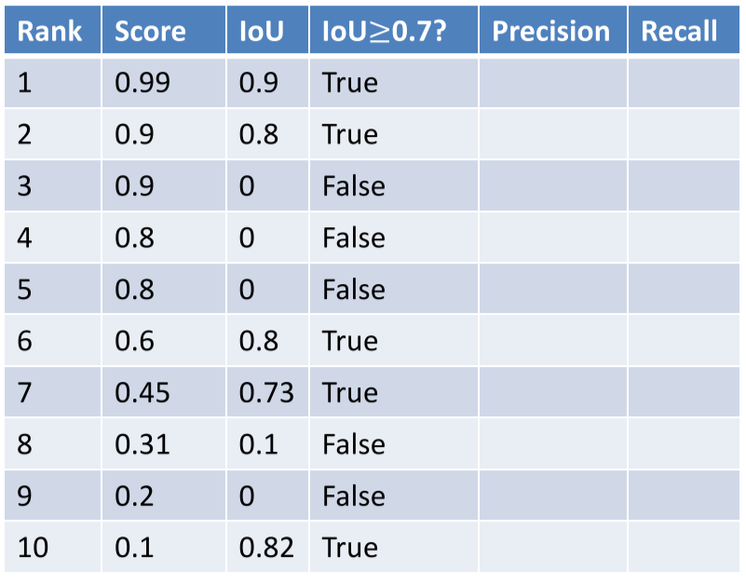

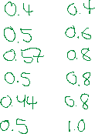

E.g. Rank 3:

3 scores that meet score threshold, 2 that meet both thresholds $$Precision=\frac{\# that meet both thresholds (i.e. IOU>threshold)}{\# that meet score threshold (i.e. rank)}=\frac{2}{3}=0.67$$

Recall is calculated with regards to the number of ground truth objects

$$Recall=\frac{\# that meet both thresholds}{\# of ground truth objects}=\frac{2}{5}=0.4$$

Plot PR curve, take monotonic interpolation, and sample precision at 11 points:

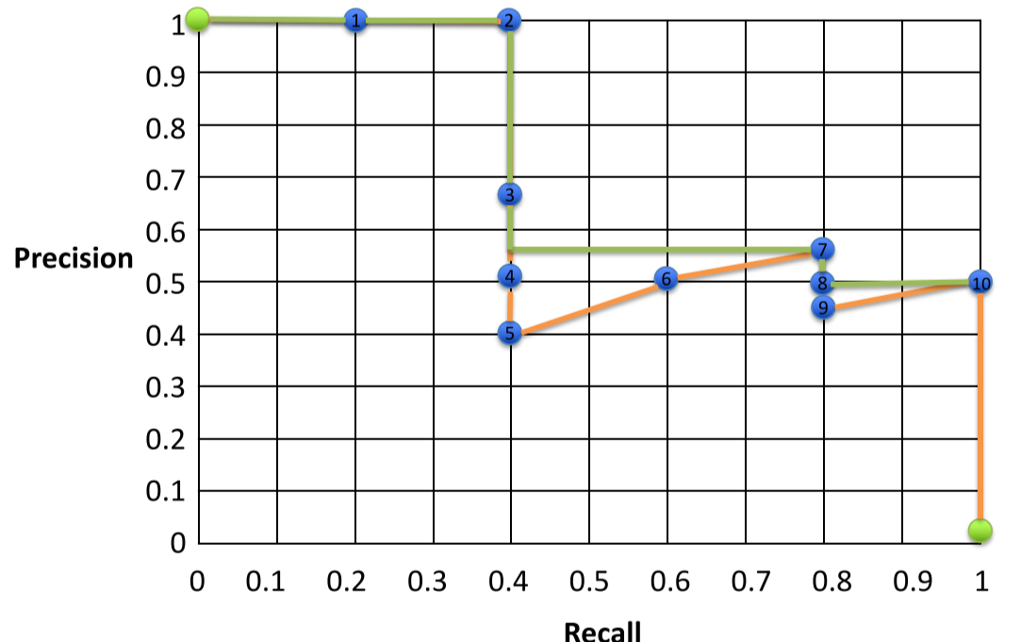



$$AP=\frac{1}{11}\left(1+1+1+1+0.57+0.57+0.57+0.57+0.57+0.5+0.5\right)=0.713$$

## ConvNets for 2D Object Detection

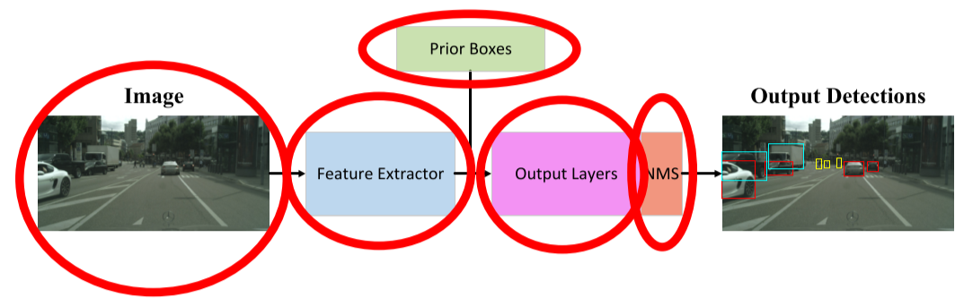

### Prior/Anchor Bounding Boxes

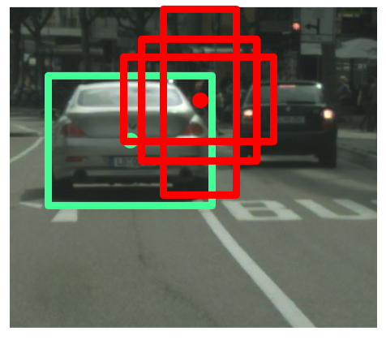

* After doing some clustering studies on ground truth labels, it turns out that most bounding boxes have certain height-width ratios
* So, instead of directly predicting height/width of a bounding box, start with a predetermined set of boxes with particular height-width ratios – the **anchor boxes**
* For each object, **predict offsets** from the nearest anchor box as the object’s bounding box

**Using Anchor Boxes**

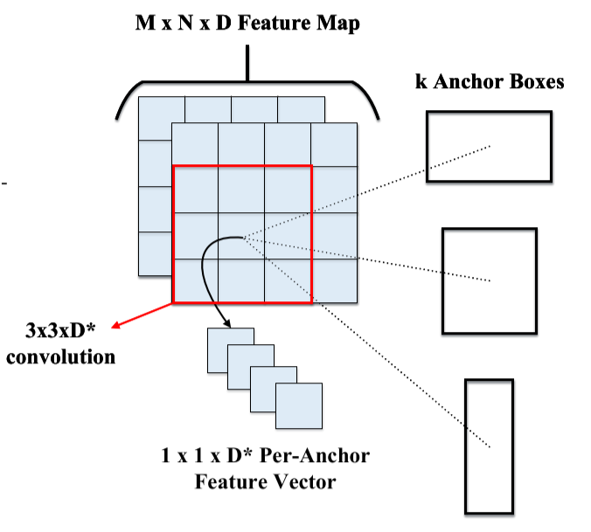

* For an $M×N×D$ feature map, apply $3×3×D^{*}$ convolution (sliding window)
* At each location, simultaneously process $k$ anchor boxes, where each location has a $1×1×D^{*}$ per-anchor feature vector

## Output Layers

### Classification vs. Regression Heads

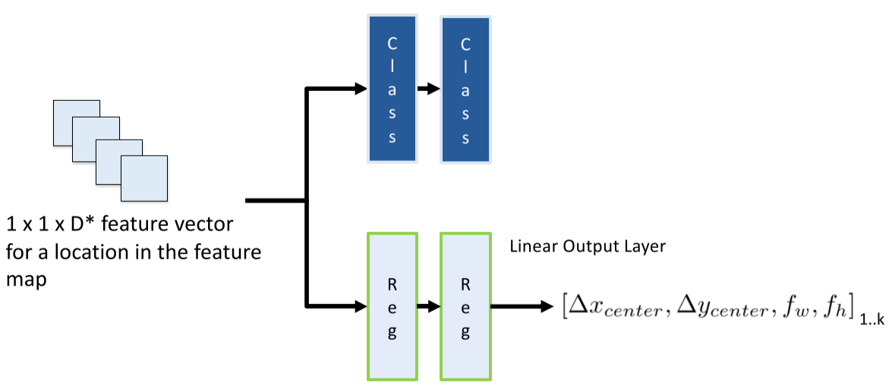

* $k$ outputs, one per anchor box
* Network estimates if there is an object for each of the anchor boxes; if there is, it adapts the anchor box dimensions as a bounding box for the object

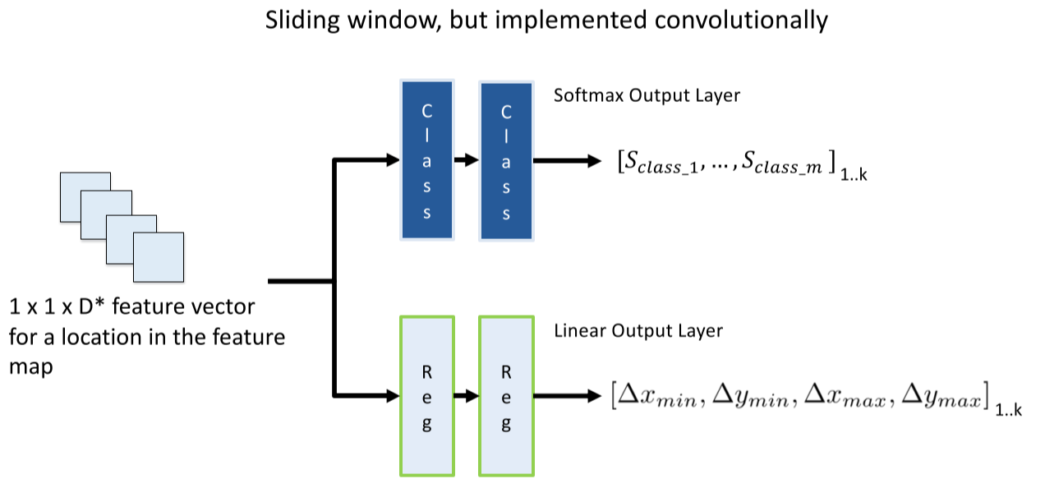

* $k$ outputs, one per anchor box
* Network estimates the applicable class for each box (if no object, use background class)
* Estimates the bounding box (if there is an object) as a residual applied to the anchor

### Object Detection in a Grid

* Feature map was reduced to 32x the original image, so effectively sliding on a grid with stride = 32
* Adding the 3x3 convolution layer, results in a **very large receptive field** (228x228 for VGG)

### Minibatch Selection

* Select a minibatch by sampling anchors over training images
* Some anchors are positive (match ground truth box), others are negative (represent background)
* Two thresholds: positive anchor threshold and negative anchor threshold
* For training, select either:
  + **Positive examples**: IOU > positive anchor threshold
  + **Negative examples**: IOU < negative anchor threshold
* **Positive anchors target**
  + Classification: category of ground truth box
  + Regression: align box parameters with highest IOU ground truth bounding box
* **Negative anchors target**
  + Classification: background
  + Regression: none
* Problem: majority of anchors are going to be negative – could teach neural network to classify everything as background
* Solution: sample a **chosen minibatch size** with 3:1 ratio of negative to positive anchors, to eliminate bias towards negative class
  + Choose negatives with **highest classification loss** to be included in the minibatch
* Example: minibatch size = 64 🡪 48 highest loss negative examples, 16 positive examples

### Classification Loss

$$L_{class}=\frac{1}{N_{total}}\sum_{i}{CrossEntropy(s_{i},s_{i}^{*})}$$

* $N_{total}$ = size of minibatch
* $s_{i}$ = output of neural network
* $s_{i}^{*}$ = anchor classification target
  + **Background** if anchor is negative
  + **Ground truth box class** if anchor is positive

### Regression Loss

$$L_{reg}=\frac{1}{N_{p}}\sum_{i}{p_{i}L_{2}(b_{i}, b_{i}^{*})}$$

* $p_{i}=0$ if negative anchor, $p_{i}=1$ if positive anchor
* $N_{p}$ = number of positive anchors in minibatch
* $b_{i}$ = estimated bounding box – obtained by applying **output** **residual** to the anchor box associated with that output
* $b_{i}^{*}$ = ground truth bounding box

## Non-Maximum Suppression (NMS)

* Finds best-match bounding box by comparing IOU values and selecting the bounding box with the highest IOU

Algorithm:

* For $b∈\overline{B}$:
 $b_{max}=b$

 + Remove $b$ from $\overline{B}$ and add to $D$
  + Then, for each element $b_{i}∈\overline{B}$:
    - If $IOU(b_{max},b_{i})≥n$, remove $b_{i}$ from $\overline{B}$ (this means they’re approximately same)
  + Return $D$

Example: $η≥0.7$

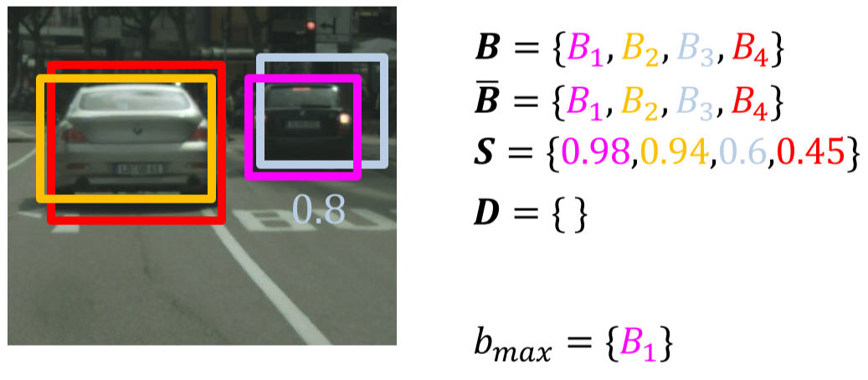

Iteration 1:

$b_{max}=B_{1}$

$\overline{B}=\{B_{2},B_{3},B_{4}\}$

$D=\{B_{1}\}$

* Compute $IOU(B_{1},B_{2}),IOU\left(B_{1},B_{3}\right),IOU(B_{1},B_{4})$; remove $B_{3}$ from $\overline{B}$

Iteration 2:

$b_{max}=B_{2}$

$\overline{B}=\{B_{4}\}$

$D=\{B_{1},B_{2}\}$

* Compute $IOU\left(B_{2},B_{4}\right)$; remove $B_{4}$ from $\overline{B}$

Return $D=\{B_{1},B_{2}\}$

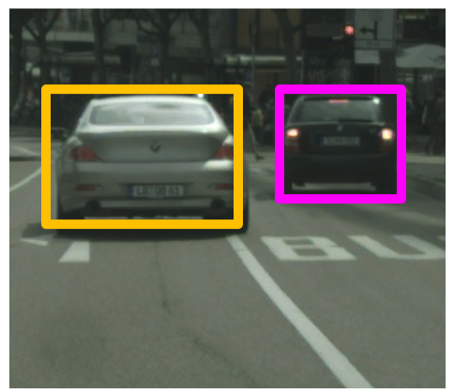

# 6-1 State Estimation: System Modelling

## Perception as State Estimation

* **Perception**: process of estimating the state of the ego and environment
  + **Belief**:the robot’s representation of the real-world ego and environment states
* Perception relies on estimation theory:
  + Sensor readings are a partial and noisy observation of real-world state
  + Models are partial and uncertain
* Use **Bayesian statistics** to update beliefs based on predictions and new observations

## State-Space System Model

* Multi-Input Multi-Output (MIMO) model maintains complete plant picture
* **System state**: a vector of system variables that entirely defines the system at a specific instance in time
  + State is a vector-valued function of time: $x\left(t\right)$ for continuous-time or $x_{t}$ for discrete time
  + E.g. at $t=0$, the initial conditions state is $x(0)$
  + Only the current state and system dynamics are needed to continue forward
* Markov Assumption: past and future states are independent, if the current state is known
  + State vector is chosen such that past history of the vector isn’t needed in order to compute the history
  + If a past value is needed, it is included in the current state vector
  + Need to balance the number of states with violations of Markov assumption
    - E.g. the older the past trajectory, the less relevant it is – use threshold to determine amount of values to keep
    - Repeated observations help compensate for lost history, by correcting wrong predictions

### Control Inputs – $u\left(t\right)$ or $u_{t}$

* Set of variables that drive the system and that can be controlled
  + Modelled by vector-valued function of time, $u(t)$ or $u_{t}$
* Common vehicle inputs:
  + Continuous: throttle, braking, steering
  + Discrete: maneuver decisions (decelerate, left/right turns, pass vehicle), car signals (indicators, horn)

### Disturbances – $ε(t)/δ(t)$ or $ε_{t}/δ_{t}$

* Set of variables that drive the system and that cannot be controlled
  + Cause uncertainty in the state
  + Modelled as random variables indexed by time, $ε(t)/δ(t)$ or $ε_{t}/δ_{t}$
* Common disturbances:
  + Sensor noise
  + Uncertainty of ML models
  + Uncontrolled phenomena (weather conditions, decisions by other drivers)
  + Unmodelled phenomena (assuming flat ground, but ground isn’t flat)

### Measurements – $y(t)$ or $y_{t}$

* Sensor outputs – provide information about the system state
  + Modelled by vector-valued function of time, $y(t)$ or $y_{t}$
* Unlike real system state, measurements come with noise and in different frames of reference

## State-Space System – General Form

**Continuous Systems**

* State equation: $\dot{x}\left(t\right)=f(x\left(t\right),u\left(t\right),ε\left(t\right),t)$
* Measurement equation: $y\left(t\right)=g(x\left(t\right),u\left(t\right),δ\left(t\right),t)$

**Discrete Systems**

* State equation: $x_{t}=f(x_{t-1},u_{t},ε_{t},t)$
* Measurement equation: $y_{t}=g(x_{t},u_{t},δ_{t},t)$

For time-invariant systems, drop the last parameter $t$ from the equations

**Continuous Linear Time-Invariant System**

* State equation: $\dot{x}\left(t\right)=Ax\left(t\right)+Bu(t)$
* Measurement equation: $y\left(t\right)=Cx\left(t\right)+Du(t)$
* $A,B,C$ and $D$ are constant matrices – state derivatives/outputs can depend on any state or input variable

**Discrete Linear Time-Invariant System**

* State equation: $x_{t}=Ax_{t-1}+Bu_{t}$
* Measurement equation: $y_{t}=Cx_{t}+Du_{t}$

### Modelling Disturbances

Disturbances are often modelled as **Gaussian noise**

$ε_{t}≈N(0,R_{t})$

$δ_{t}≈N(0,Q_{t})$

This is often reasonable due to **central limit theorem**: when independent random variables are added, their normalized sum tends toward a normal distribution

### Other Common State-Space System Types

* **Linear Time-Invariant with Gaussian disturbance $$x_{t}=Ax_{t-1}+Bu_{t}+ε_{t} \\ y_{t}=Cx_{t}+Du_{t}+δ_{t}$$**
* **Linear Time-Variant with Gaussian disturbance $$x_{t}=A_{t}x_{t-1}+B_{t}u_{t}+ε_{t} \\ y_{t}=C_{t}x_{t}+D_{t}u_{t}+δ_{t}$$**
* **Non-Linear Time-Invariant with Gaussian disturbance $$x_{t}=f(x_{t-1},u_{t})+ε_{t} \\ y_{t}=g(x_{t},u_{t})+δ_{t}$$**
* **Non-Linear Time-Variant with Non-Linear disturbance $$x_{t}=f(x_{t-1},u_{t},ε_{t}) \\ y_{t}=g(x_{t},u_{t},δ_{t})$$**